**NAME: BINYANYA DEBORAH NYATICHI**

**CS NO: ADC-CSS02-25051**.

**DESCRIPTION: Week 2 Assignment 3**

**ASSIGNMENT: Lab on Microsoft Identity and Access Management Solutions**

**DATE: 05/04/2025**

INTRODUCTION

In today's digital landscape, robust identity management is paramount for security, compliance, and user productivity. This lab series is designed to provide you with hands-on experience in key components of Microsoft's cutting-edge IAM platform, Microsoft Entra ID (formerly Azure AD).mThrough a series of focused labs, you will delve into critical functionalities that empower organizations to manage user identities, secure access to resources, and streamline administrative tasks. We will move beyond theoretical concepts and provide practical scenarios where you can configure and observe these powerful features in action.

This lab will guide you through the following essential areas:

* **Explore Microsoft Entra ID User Settings:** Gain a foundational understanding of how user accounts are managed within Microsoft Entra ID, including profile settings, contact information, and organizational relationships.
* **Microsoft Entra self-service password reset (SSPR):** Discover how to empower users to securely reset their own passwords, reducing helpdesk burden and improving user convenience.
* **Microsoft Entra Conditional Access:** Learn how to implement granular access control policies based on various conditions, such as user location, device compliance, and application sensitivity, to enhance security.
* **Explore Privileged Identity Management (PIM):** Understand how to manage, control, and monitor access to important resources within your organization by implementing just-in-time and approval-based privileged access.

# Lab: Explore Privileged Identity management

This lab maps to the following Learn content:

Learning Path: Describe the capabilities of Microsoft Entra

Module: Describe the identity protection and governance capabilities of Microsoft Entra

Unit: Describe the capabilities of Privileged Identity Management

# Lab scenario

In this lab, you'll explore some of the basic functionality of Privileged Identity Management (PIM). PIM does require Microsoft Entra ID P2 licensing. In this lab, you, as the admin, will configure one of your users, Diego Siciliani, with a Microsoft Entra user administrator role, through Privileged ID management (PIM). With user admin privileges, Diego will be able to create users and groups manage licenses, and more. Both the admin and the user, Diego, must be configured for Microsoft Entra ID P2 licensing.

## Task 1

In this task you, as the admin, will reset the password for the user Diego Siciliani. This step is needed so you can initially sign in as the user in subsequent tasks.

Open Microsoft Edge. In the address bar, enter <https://entra.microsoft.com>.

Sign in with the Microsoft 365 admin credentials provided by your ALH.

In the Sign-in window, enter admin@WWLx730857.onmicrosoft.com (where ZZZZZZ is your unique tenant ID provided by your ALH) then select Next.

Enter the admin password that should be provided by your lab hosting provider. Select Sign in.

Depending on your lab hoster and if this is the first time you are logging in to the tenant, you may be prompted to complete the MFA registration process. If so, follow the prompts on the screen to setup MFA.

Once you're signed-in, you're taken to the Microsoft 365 admin center page.

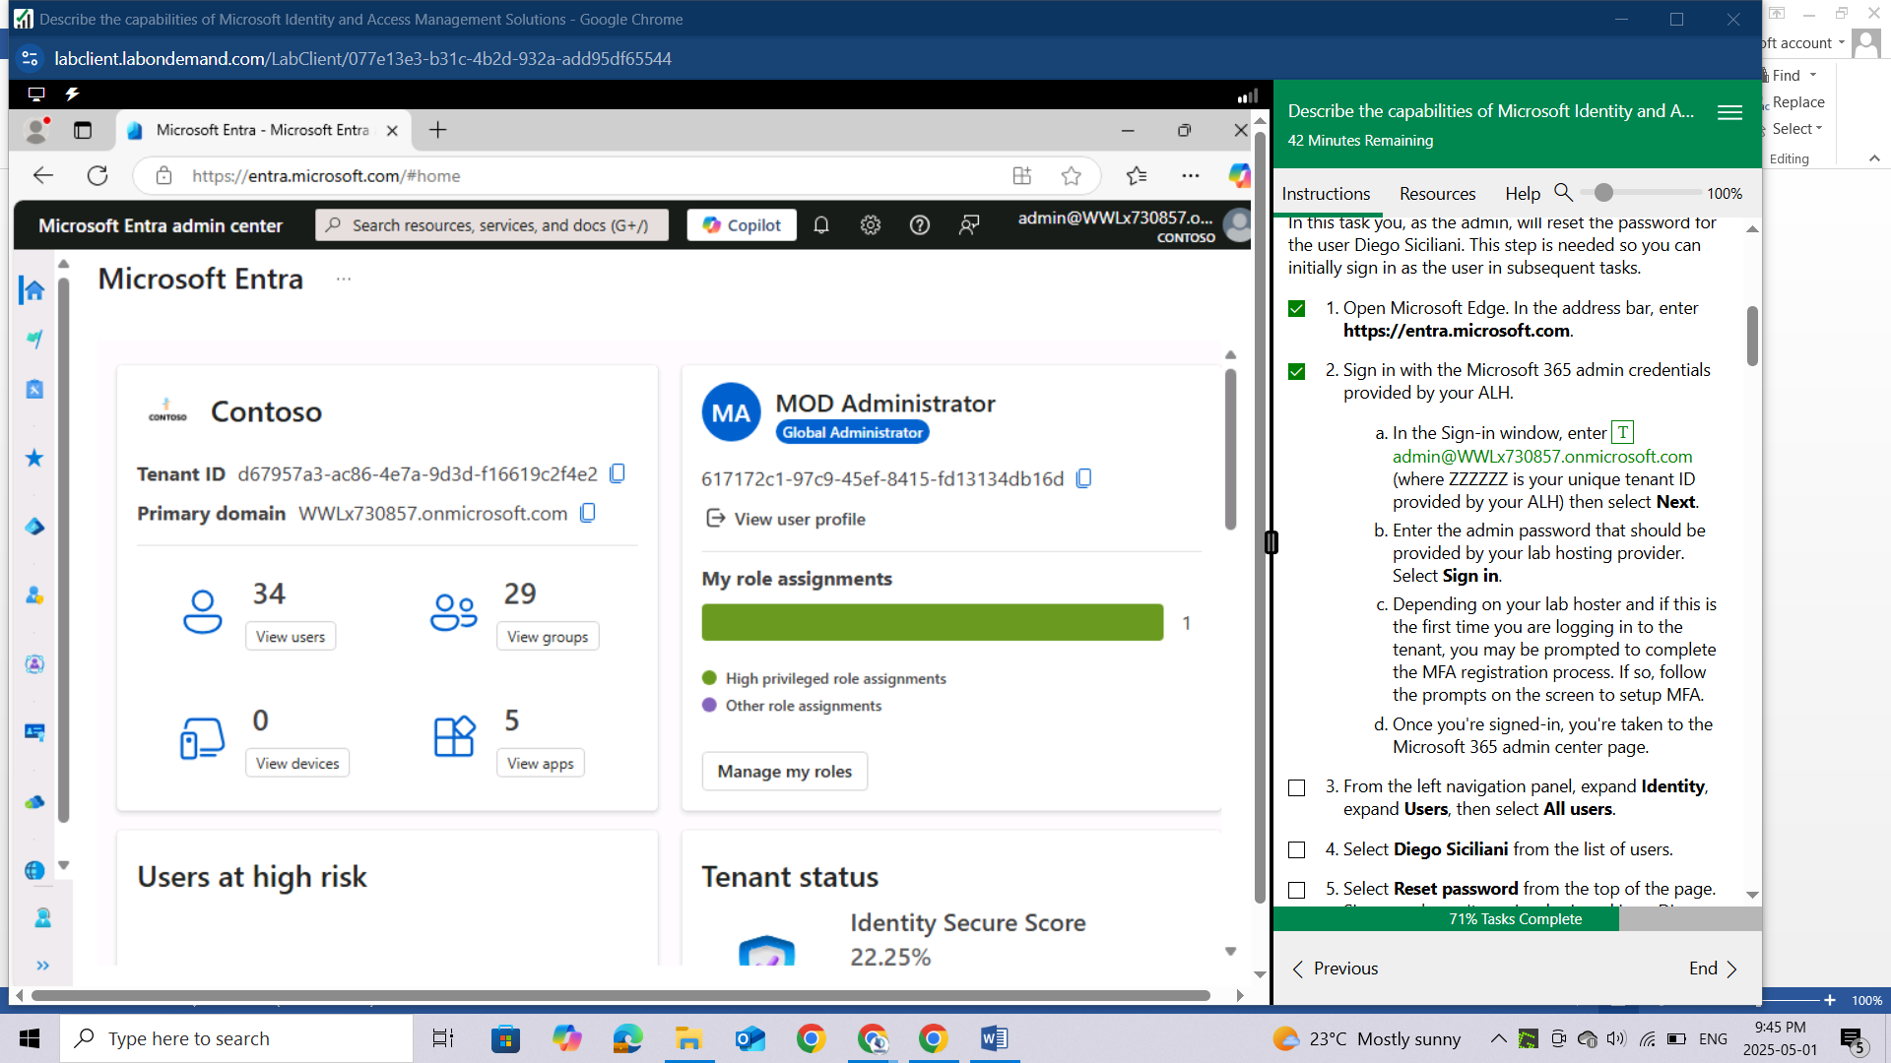

From the left navigation panel, expand Identity, expand Users, then select All users.

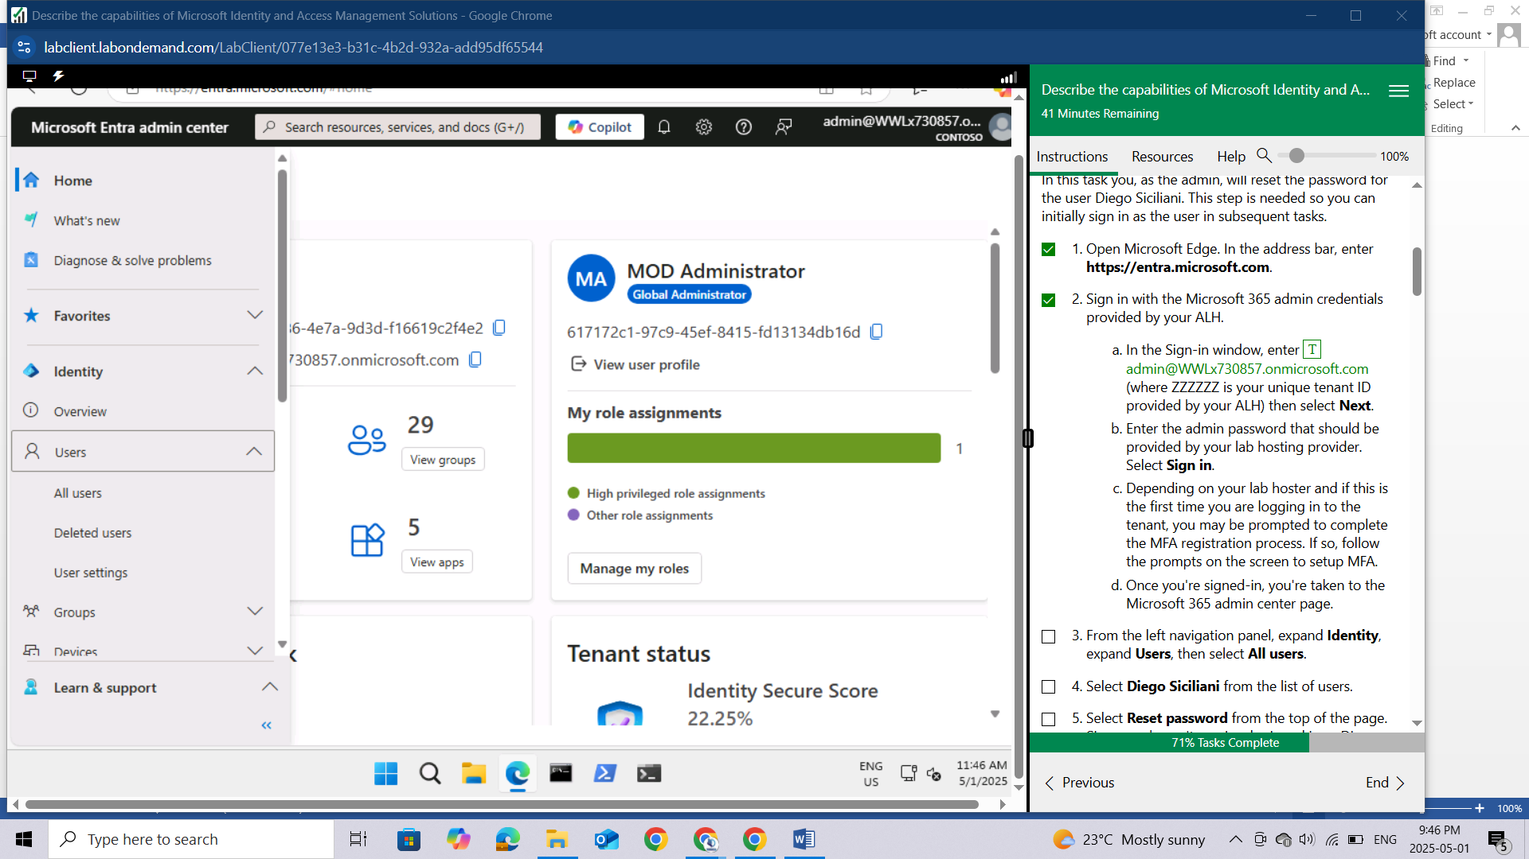

Select Diego Siciliani from the list of users.

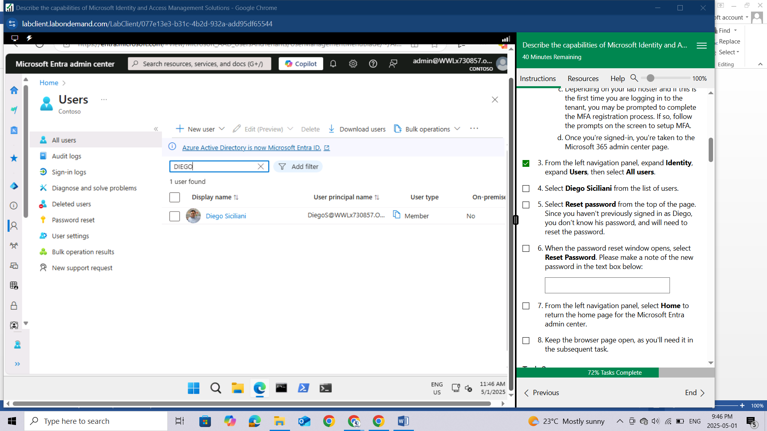

Select Reset password from the top of the page. Since you haven't previously signed in as Diego, you don’t know his password, and will need to reset the password.

When the password reset window opens, select Reset Password. Please make a note of the new password in the text box below:

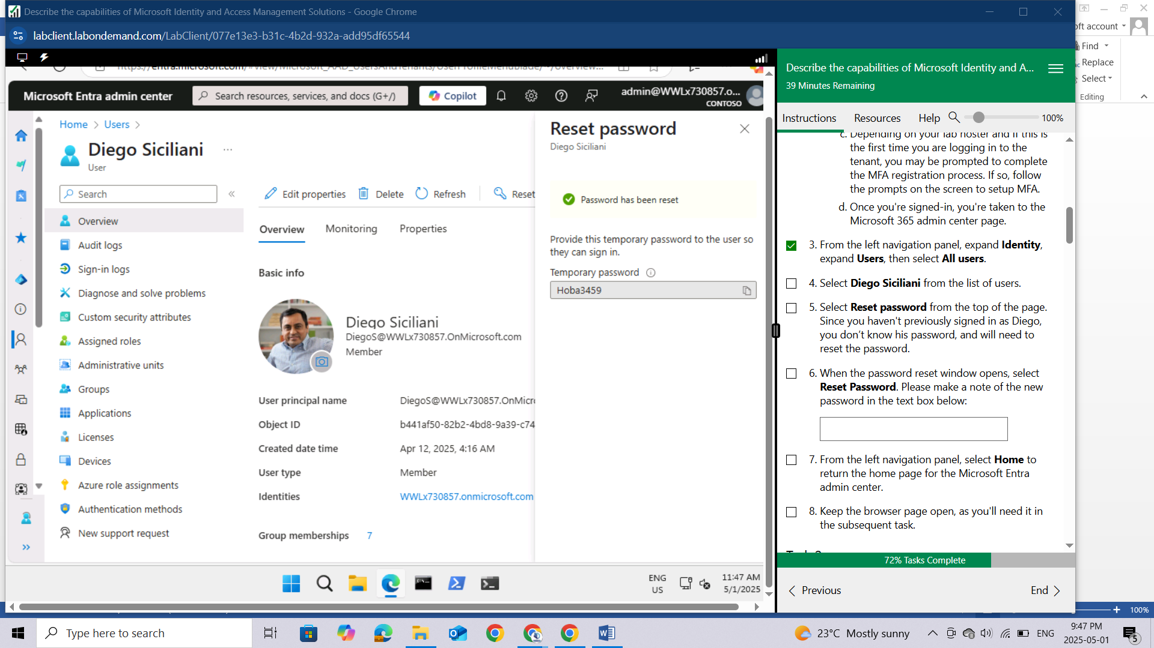

From the left navigation panel, select Home to return the home page for the Microsoft Entra admin center.

Keep the browser page open, as you'll need it in the subsequent task.

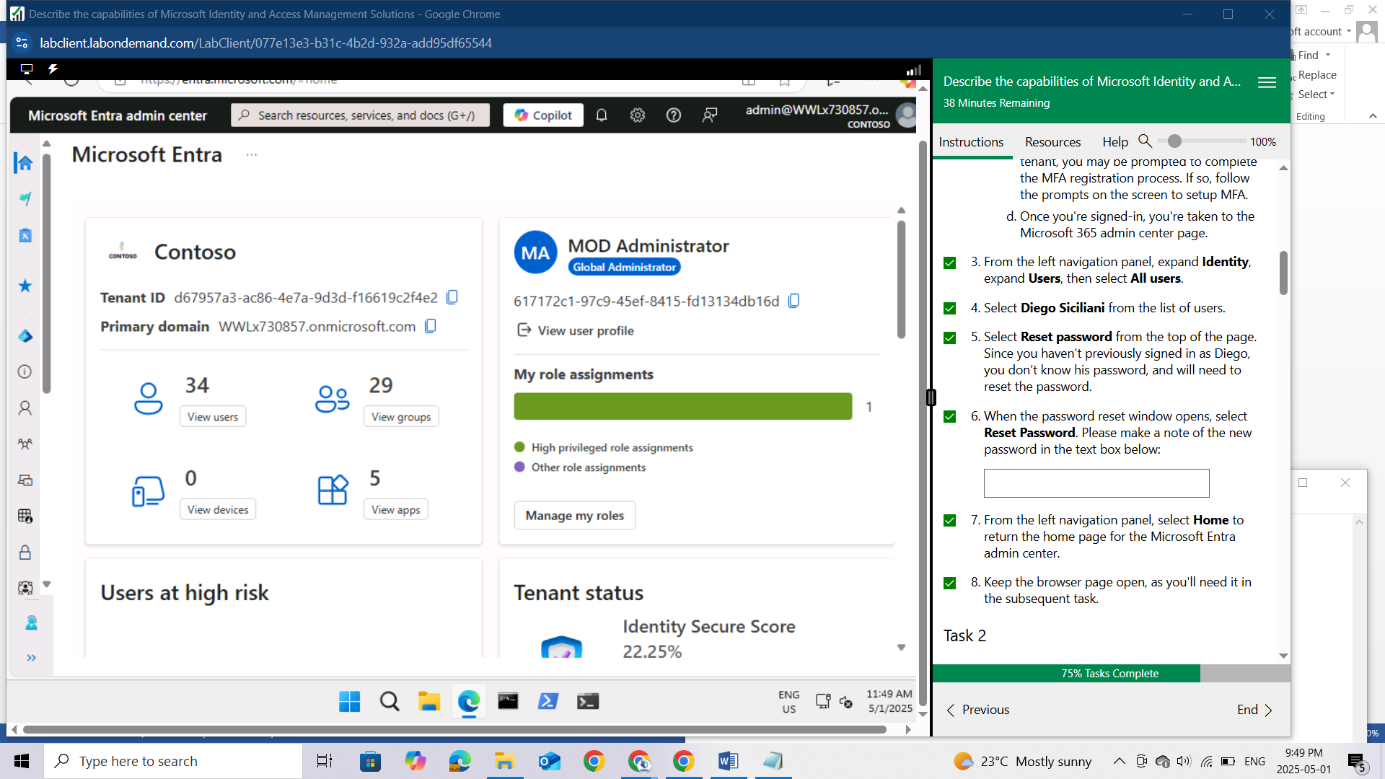

## Task 2

In this task you, as the admin, will assign Diego a Microsoft Entra ID role in Privileged Identity Management.

Open the browser tab for the home page of the Microsoft Entra admin center.

From the left navigation panel, under "**Identity**", expand **Identity Governance**, then select **Privileged Identity Management.**

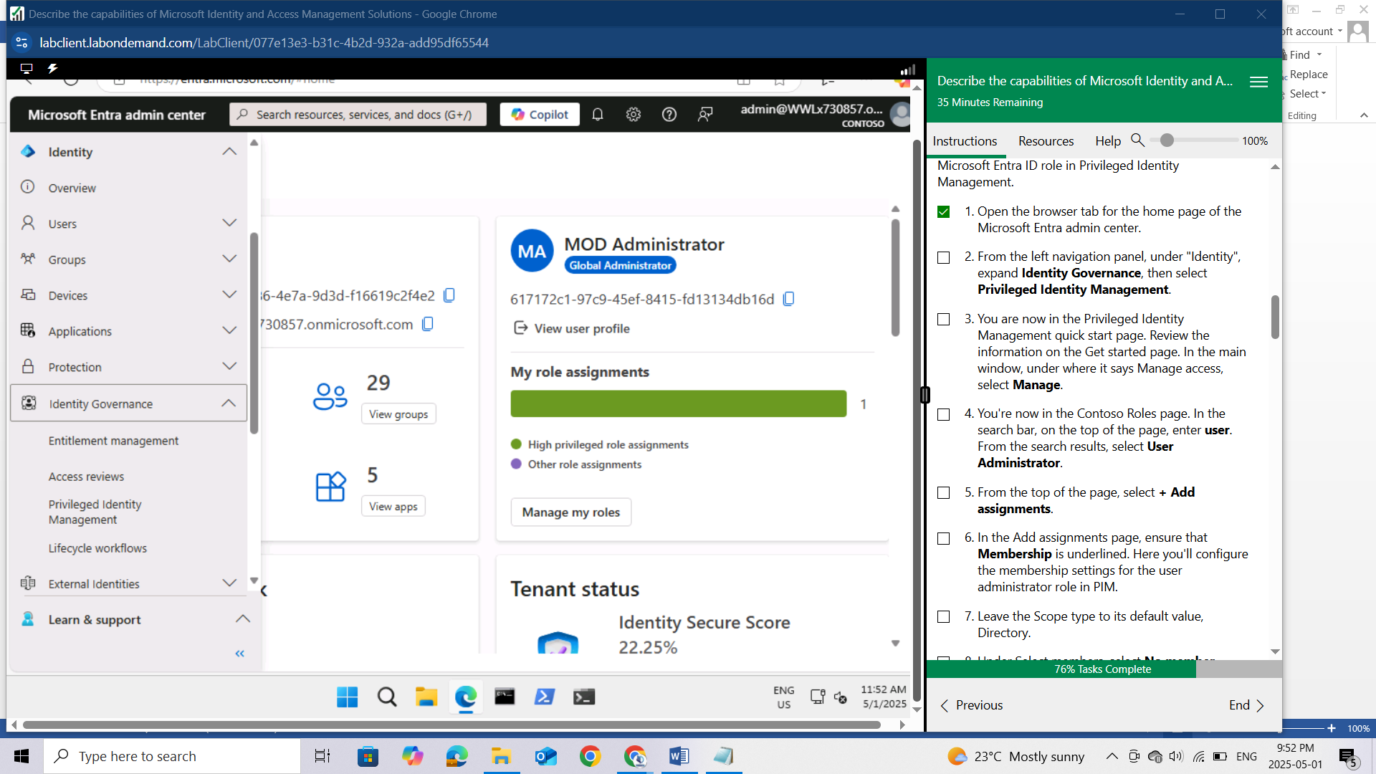

You are now in the Privileged Identity Management quick start page. Review the information on the Get started page. In the main window, under where it says Manage access, select Manage.

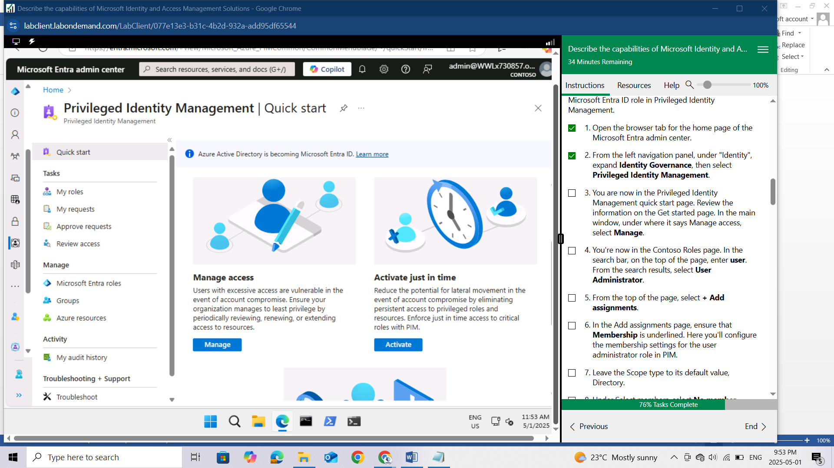

You're now in the Contoso Roles page. In the search bar, on the top of the page, enter **user**. From the search results, select **User Administrator**.

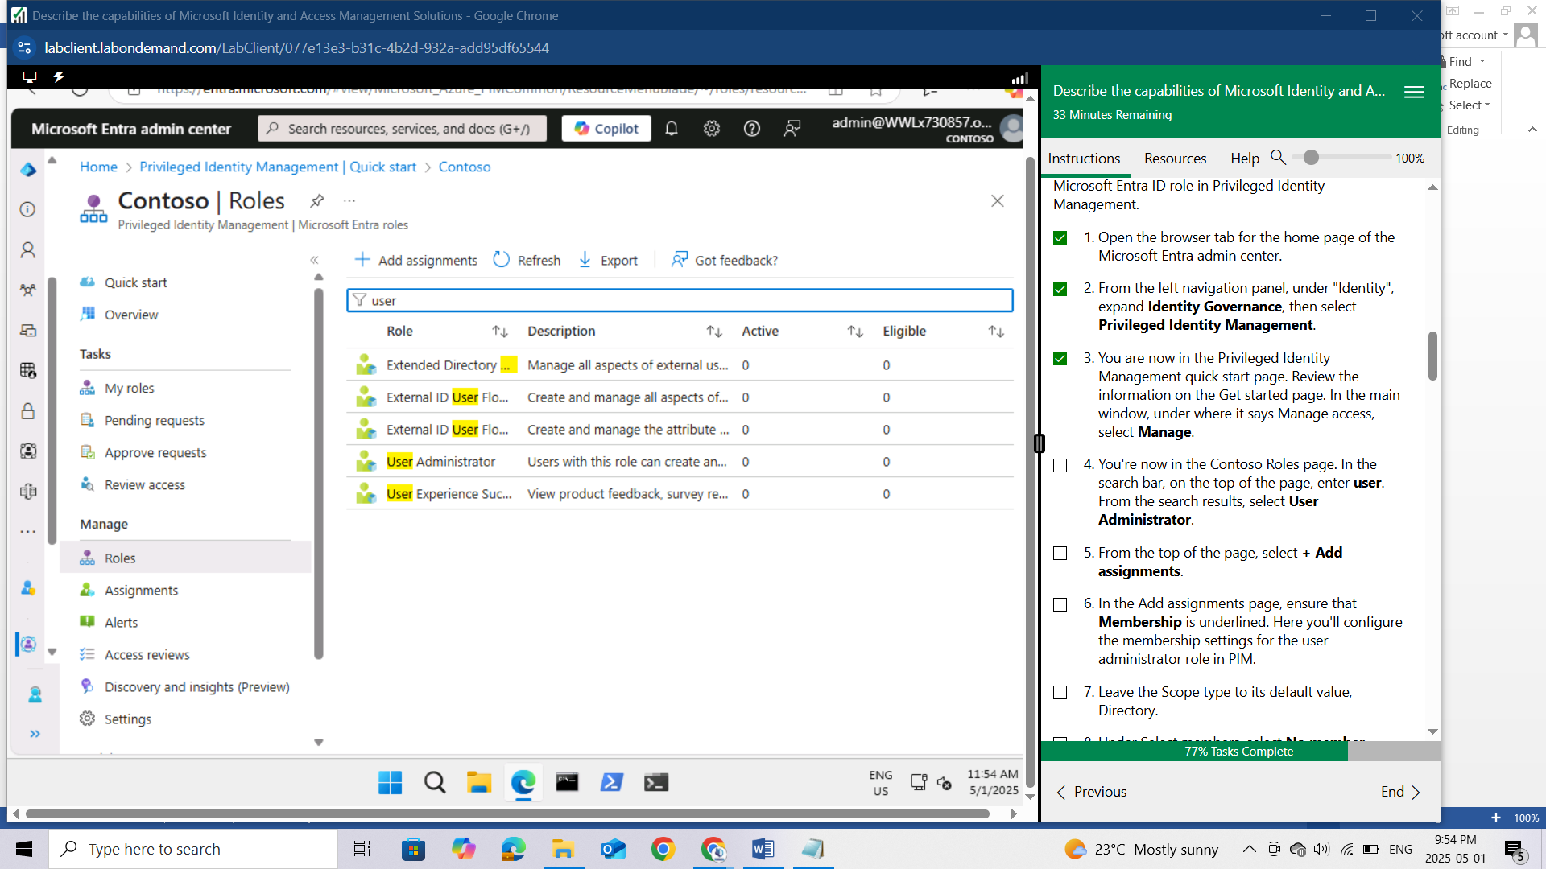

From the top of the page, select + Add assignments.

In the Add assignments page, ensure that **Membership** is underlined. Here you'll configure the membership settings for the user administrator role in PIM.

Leave the Scope type to its default value, **Directory**.

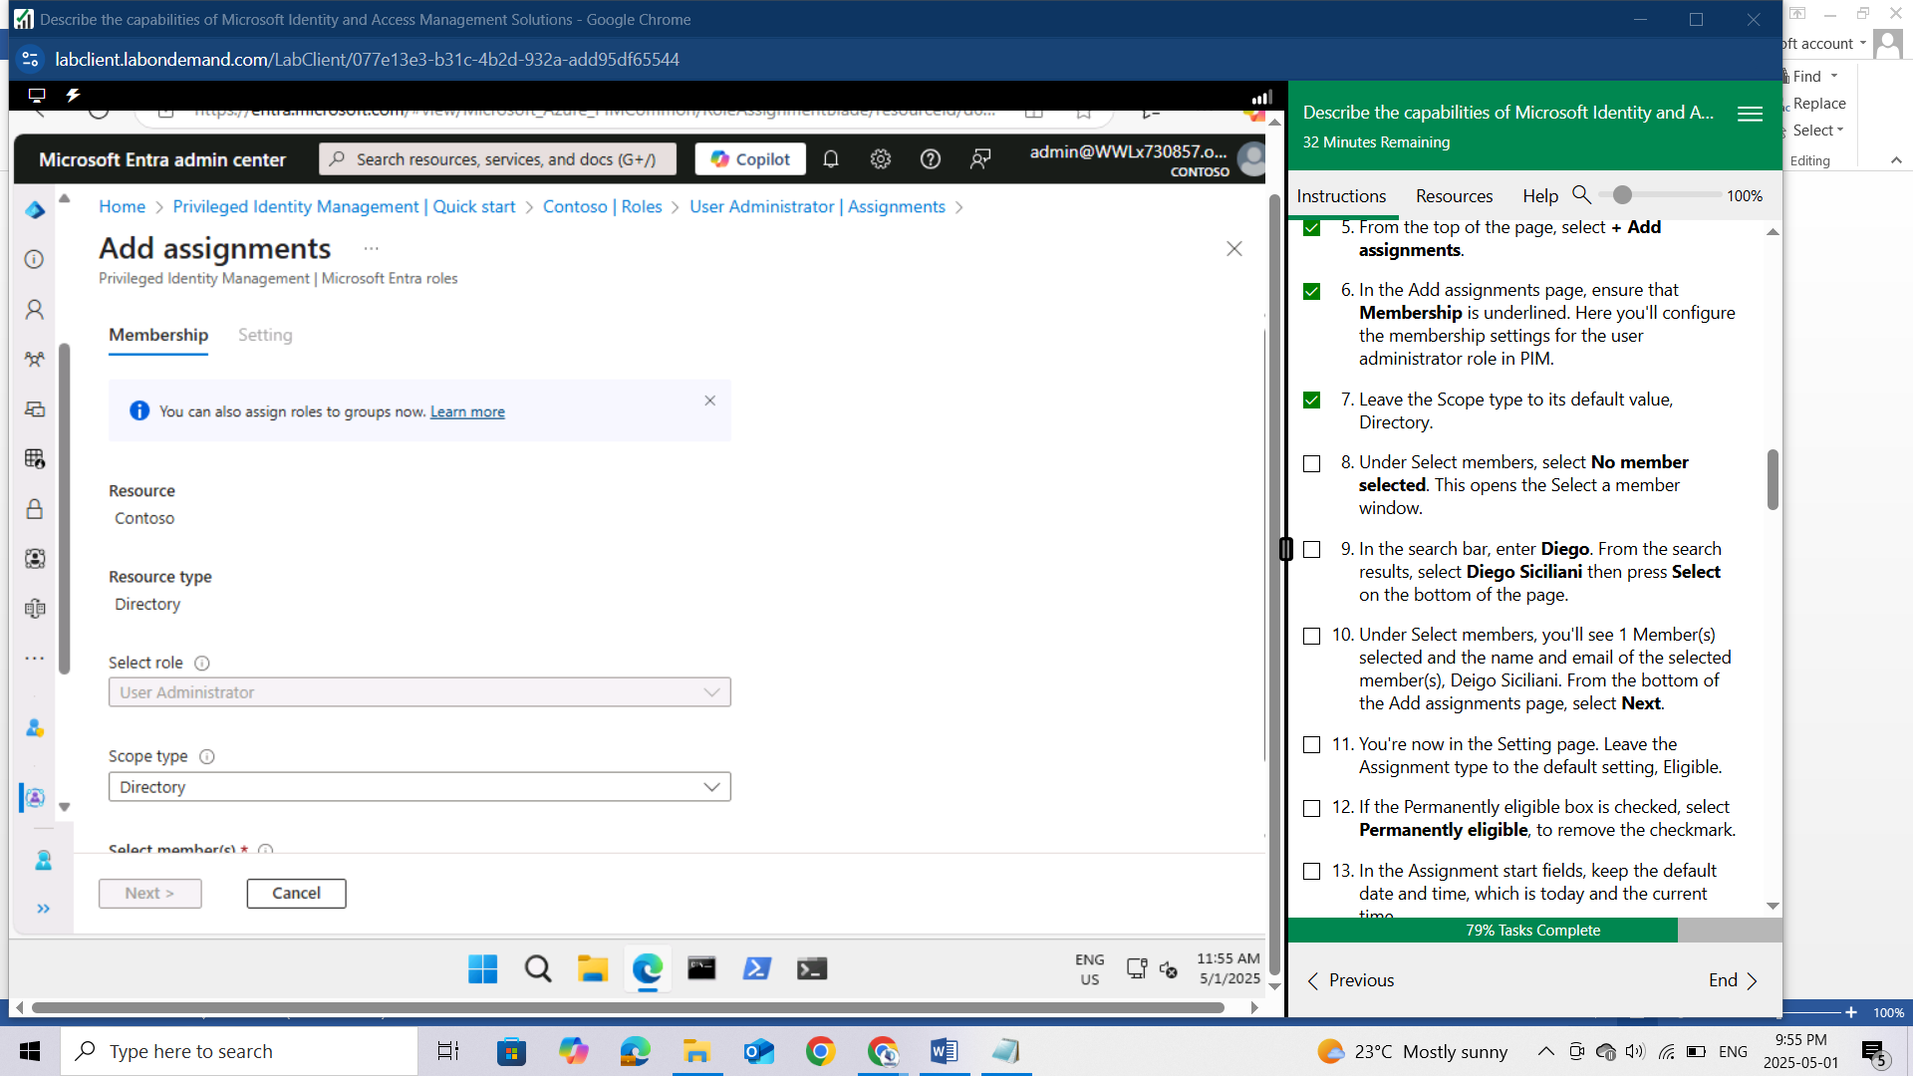

Under Select members, select No member selected. This opens the Select a member window.

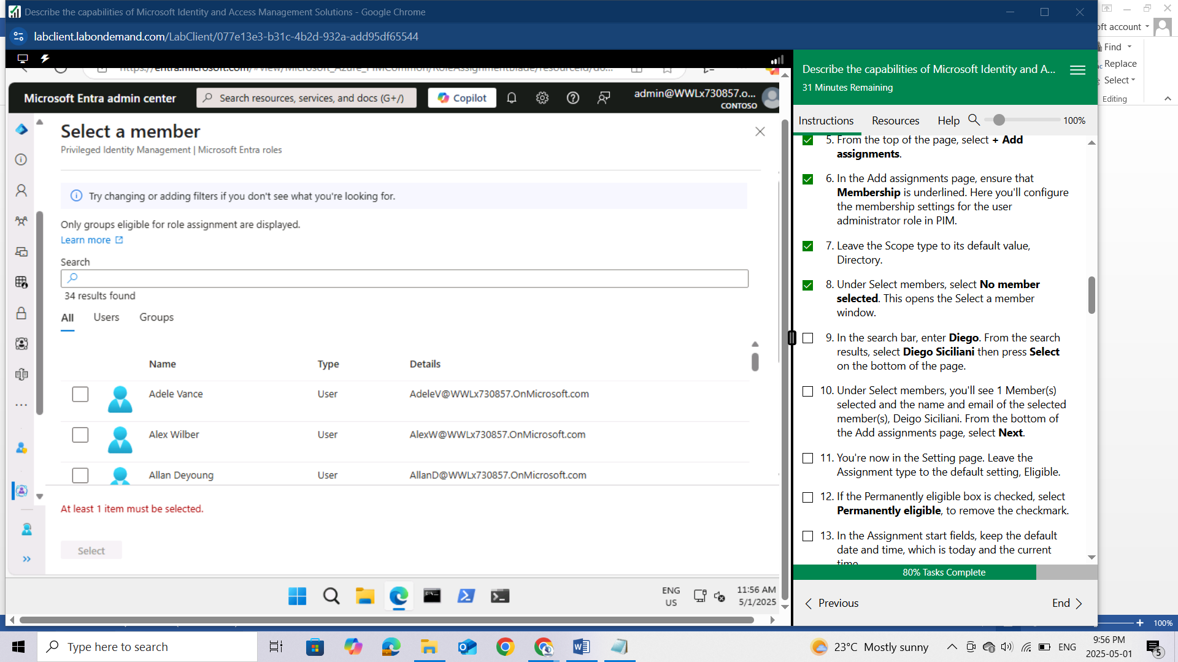

In the search bar, enter Diego. From the search results, select Diego Siciliani then press Select on the bottom of the page.

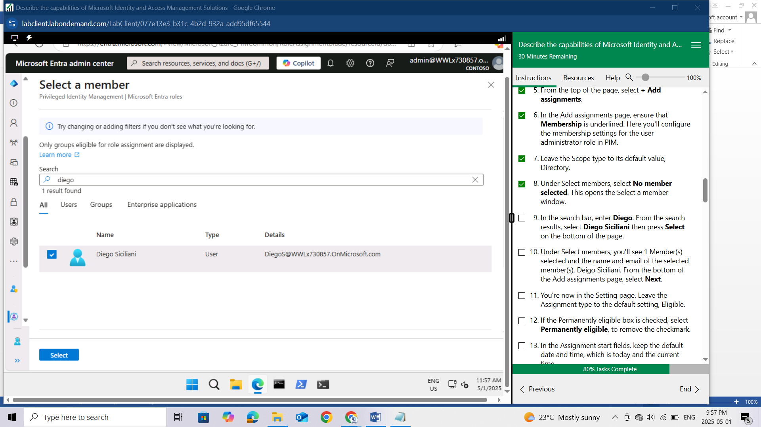

Under Select members, you'll see 1 Member(s) selected and the name and email of the selected member(s), Deigo Siciliani. From the bottom of the Add assignments page, select Next.

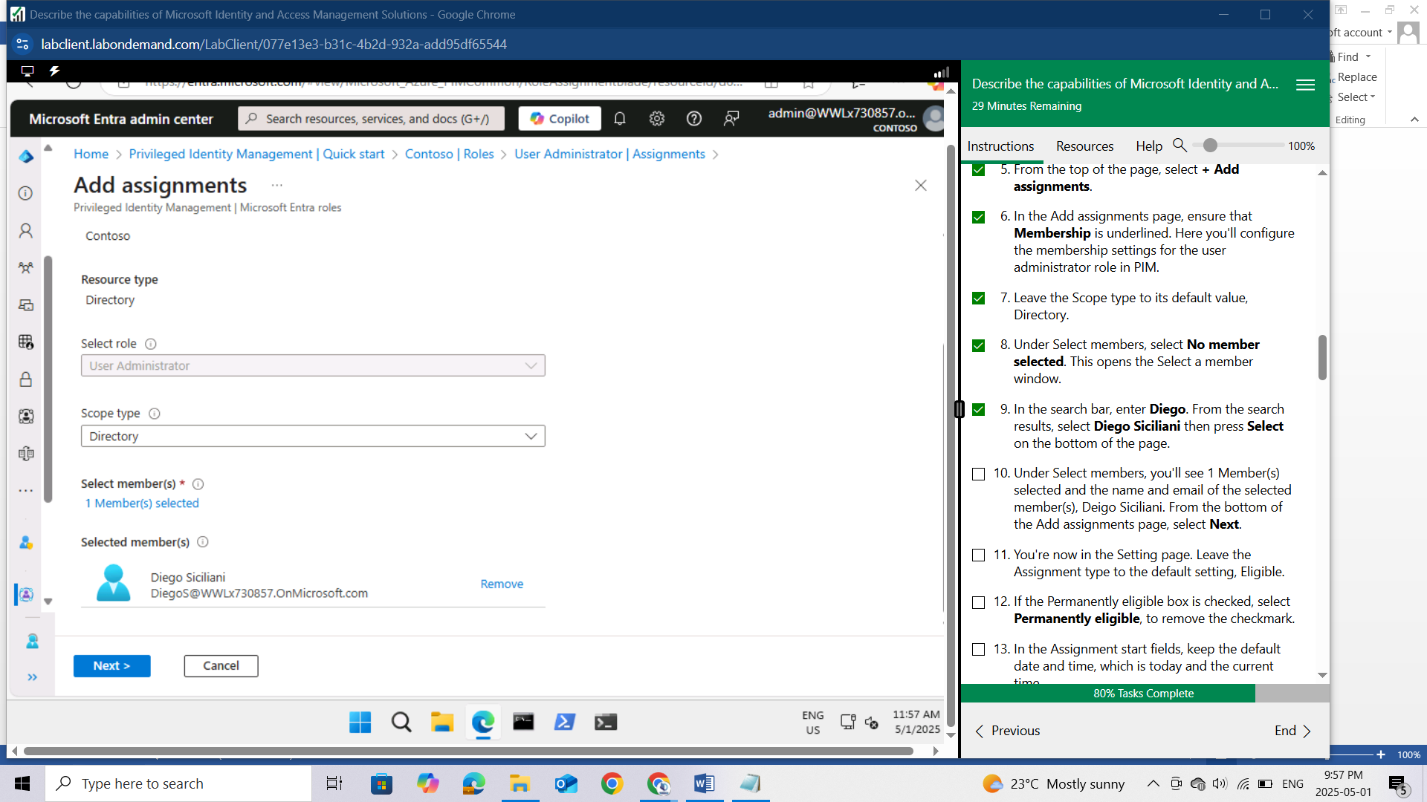

You're now in the Setting page. Leave the Assignment type to the default setting, Eligible.

If the Permanently eligible box is checked, select Permanently eligible, to remove the checkmark.

In the Assignment start fields, keep the default date and time, which is today and the current time.

In the Assignment end fields, change the date to today’s date (note the default setting is one year from the today, so you need to change the year). For the time, set the time to two hours from the current time. After you have set the time field for the time when the Assignment ends, press the tab key on your keyboard and select Assign on the bottom of the page.

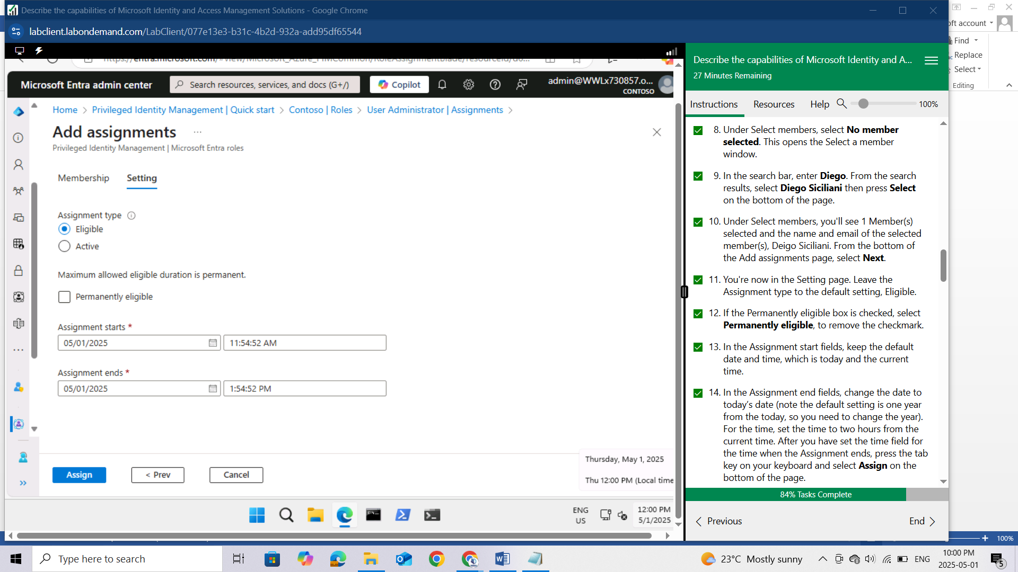

This takes you back the Assignments window. After a few second you should see Diego Siciliani listed in the User Administrator table, along with the details of the assignment. If after a few seconds you still don't see the update, select Refresh from the top of the page.

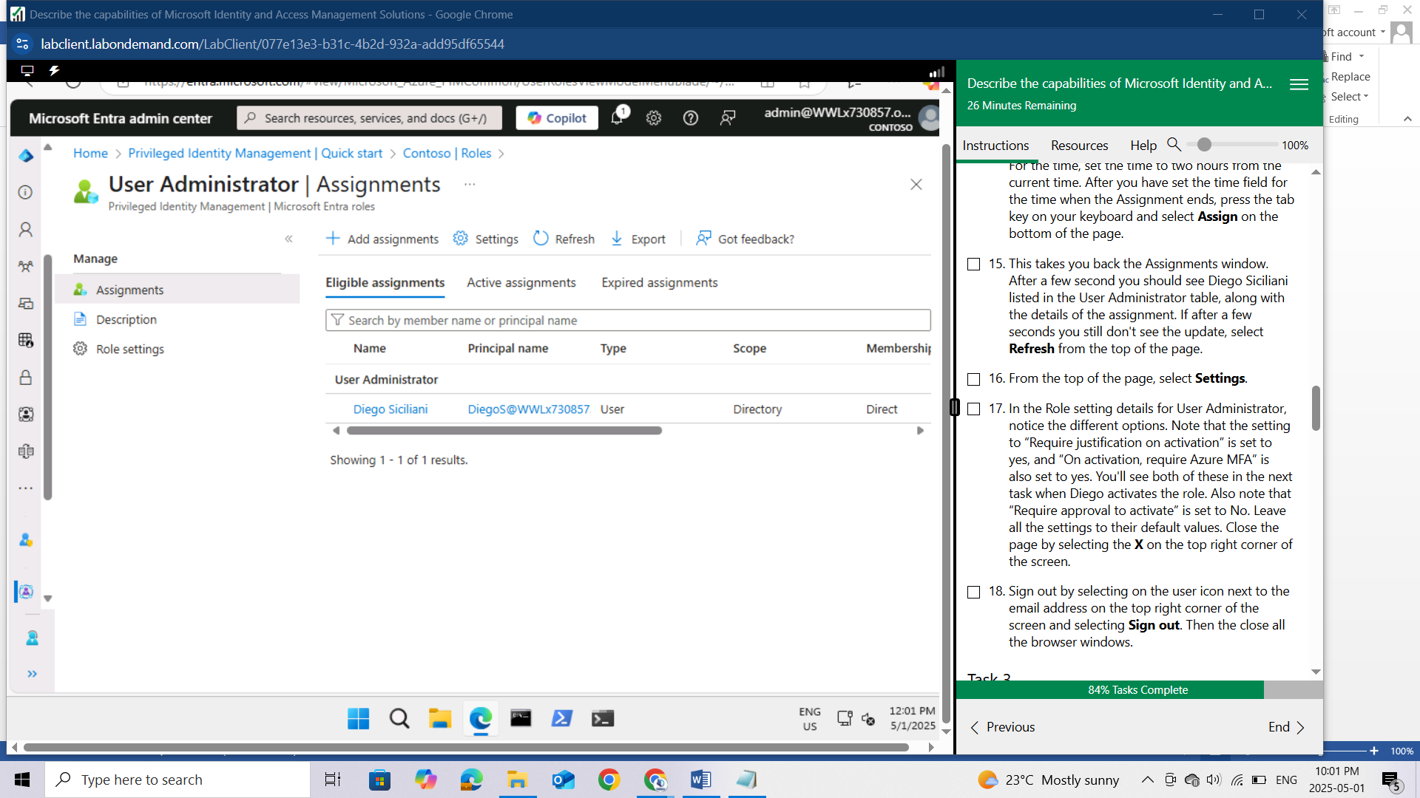

From the top of the page, select Settings.

In the Role setting details for User Administrator, notice the different options. Note that the setting to “Require justification on activation” is set to yes, and “On activation, require Azure MFA” is also set to yes. You'll see both of these in the next task when Diego activates the role. Also note that “Require approval to activate” is set to No. Leave all the settings to their default values. Close the page by selecting the X on the top right corner of the screen.

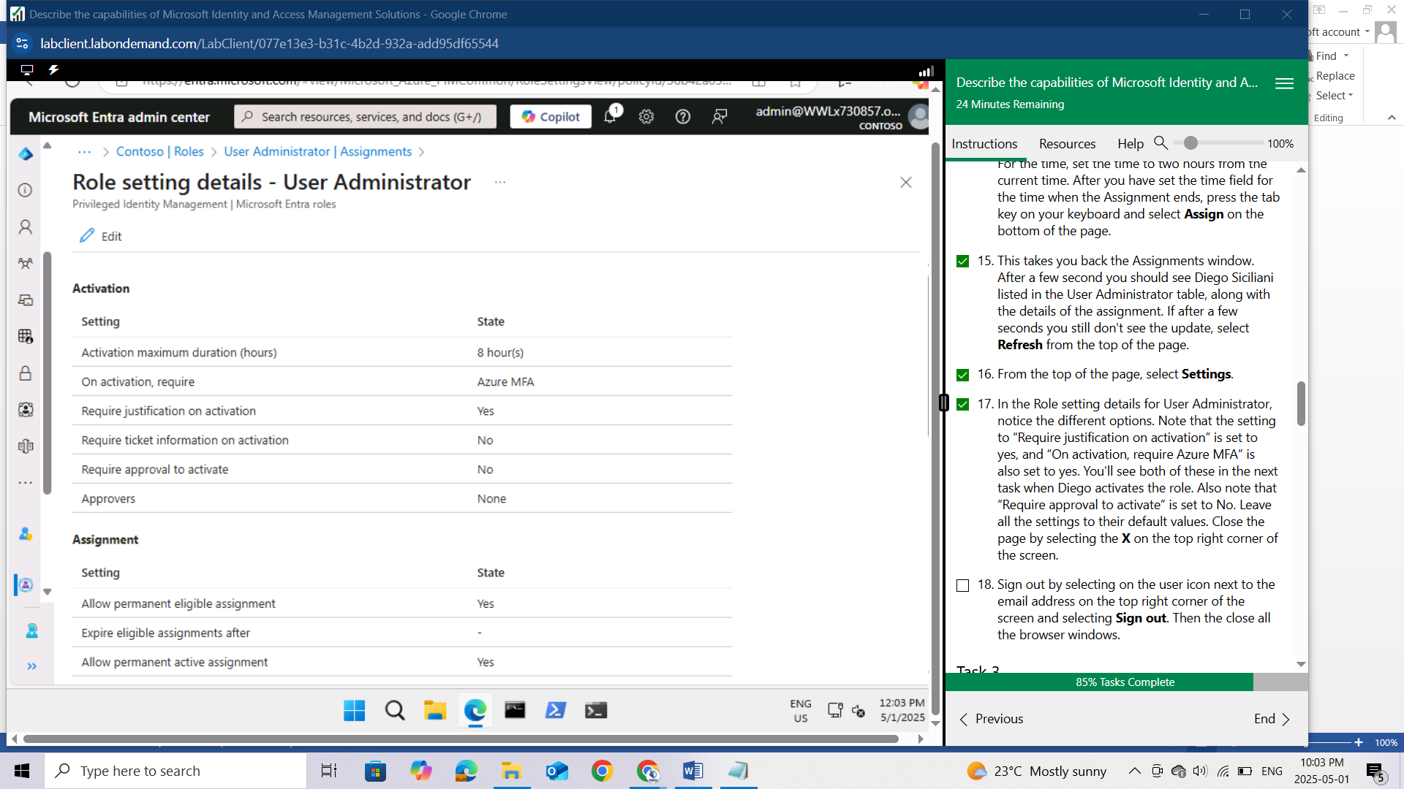

Sign out by selecting on the user icon next to the email address on the top right corner of the screen and selecting Sign out. Then the close all the browser windows.

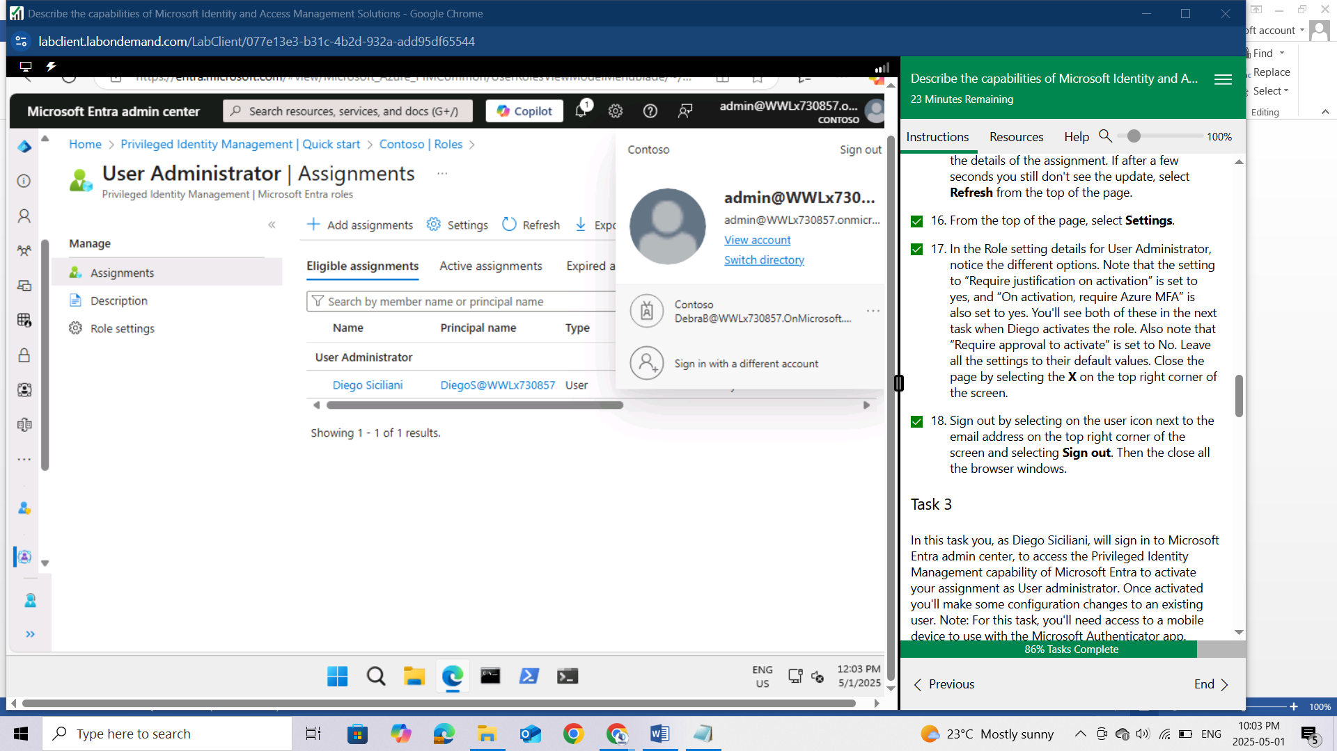

## Task 3

In this task you, as Diego Siciliani, will sign in to Microsoft Entra admin center, to access the Privileged Identity Management capability of Microsoft Entra to activate your assignment as User administrator. Once activated you'll make some configuration changes to an existing user. Note: For this task, you'll need access to a mobile device to use with the Microsoft Authenticator app.

Open Microsoft Edge. In the address bar of the browser, enter Entra.microsoft.com.

Sign in as Diego Siciliani.

In the Sign-in window, enter DiegoS@WWLx730857.onmicrosoft.com (where ZZZZZZ is your unique tenant ID provided by your lab hosting provider) then select Next.

Enter the temporary password that you noted from the previous task and select Sign in. Select Sign in.

Since the password you entered was only a temporary password, you need to update now. Enter the current password, enter a new password, then confirm the new password. Make note of this new password as you will need to complete the task.

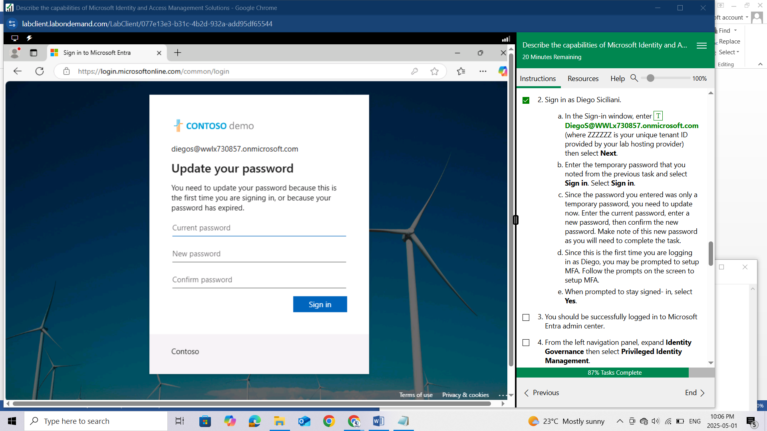

Since this is the first time you are logging in as Diego, you may be prompted to setup MFA. Follow the prompts on the screen to setup MFA.

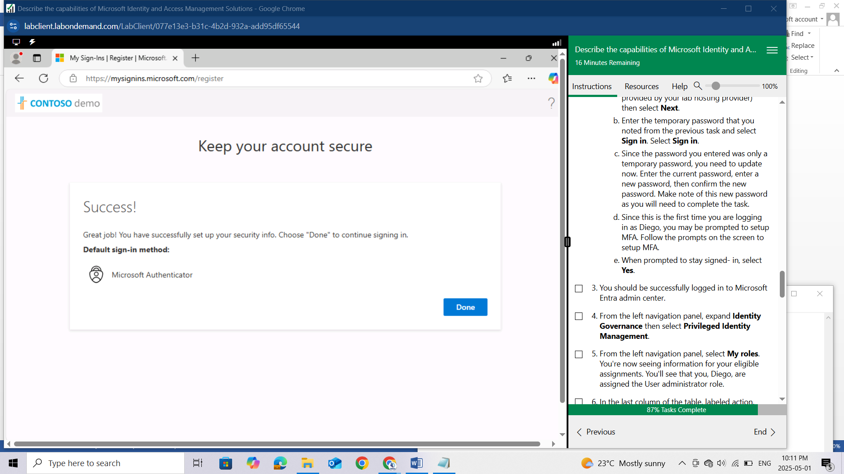

When prompted to stay signed- in, select Yes.

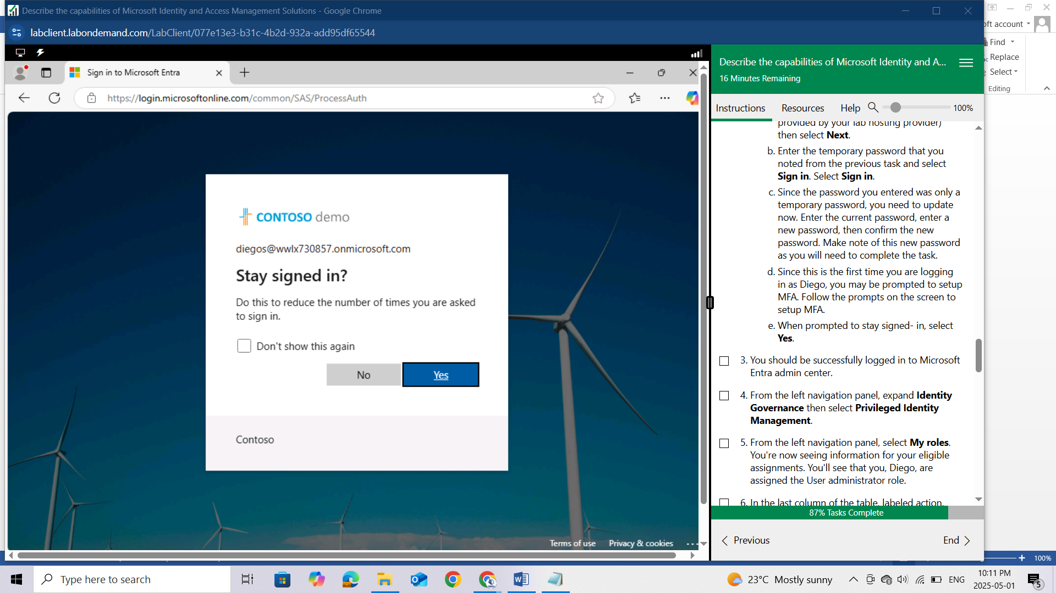

You should be successfully logged in to Microsoft Entra admin center.

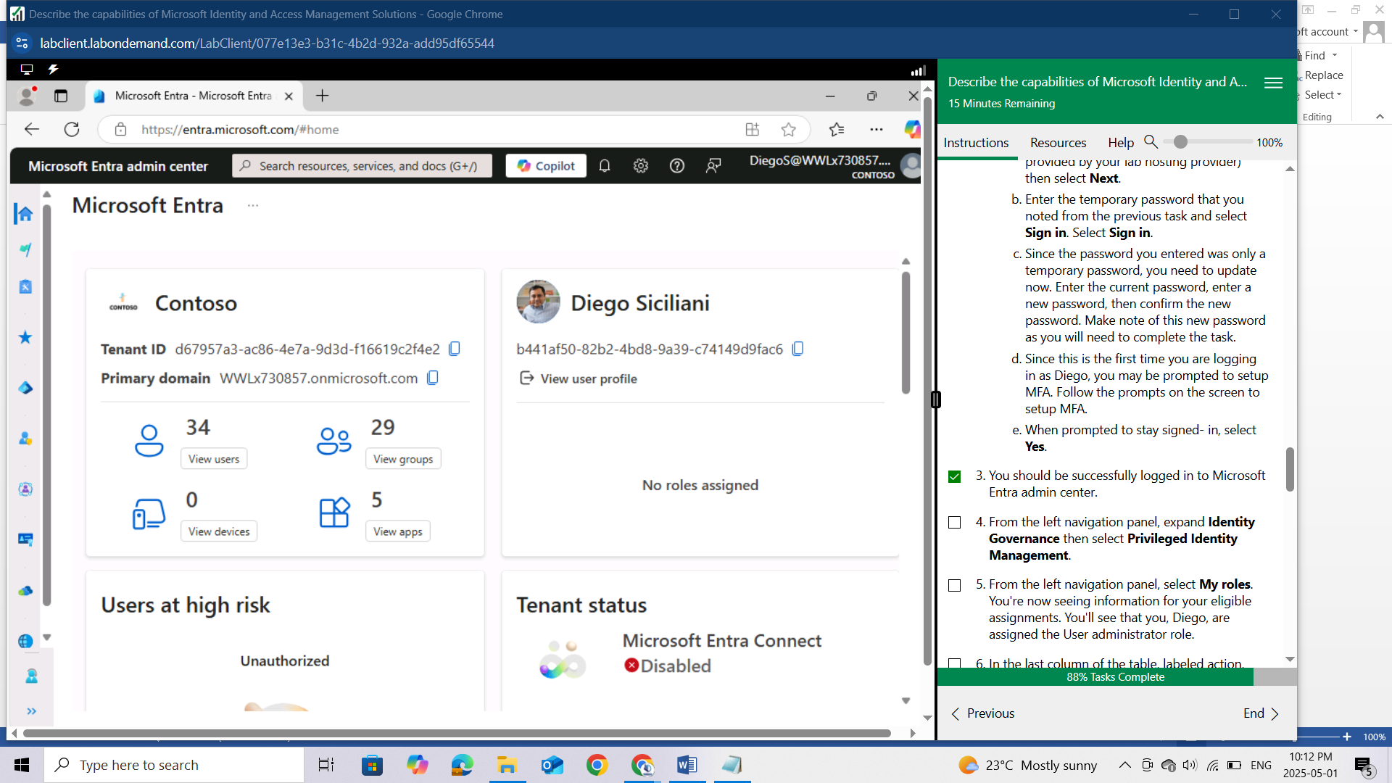

From the left navigation panel, expand Identity Governance then select Privileged Identity Management.

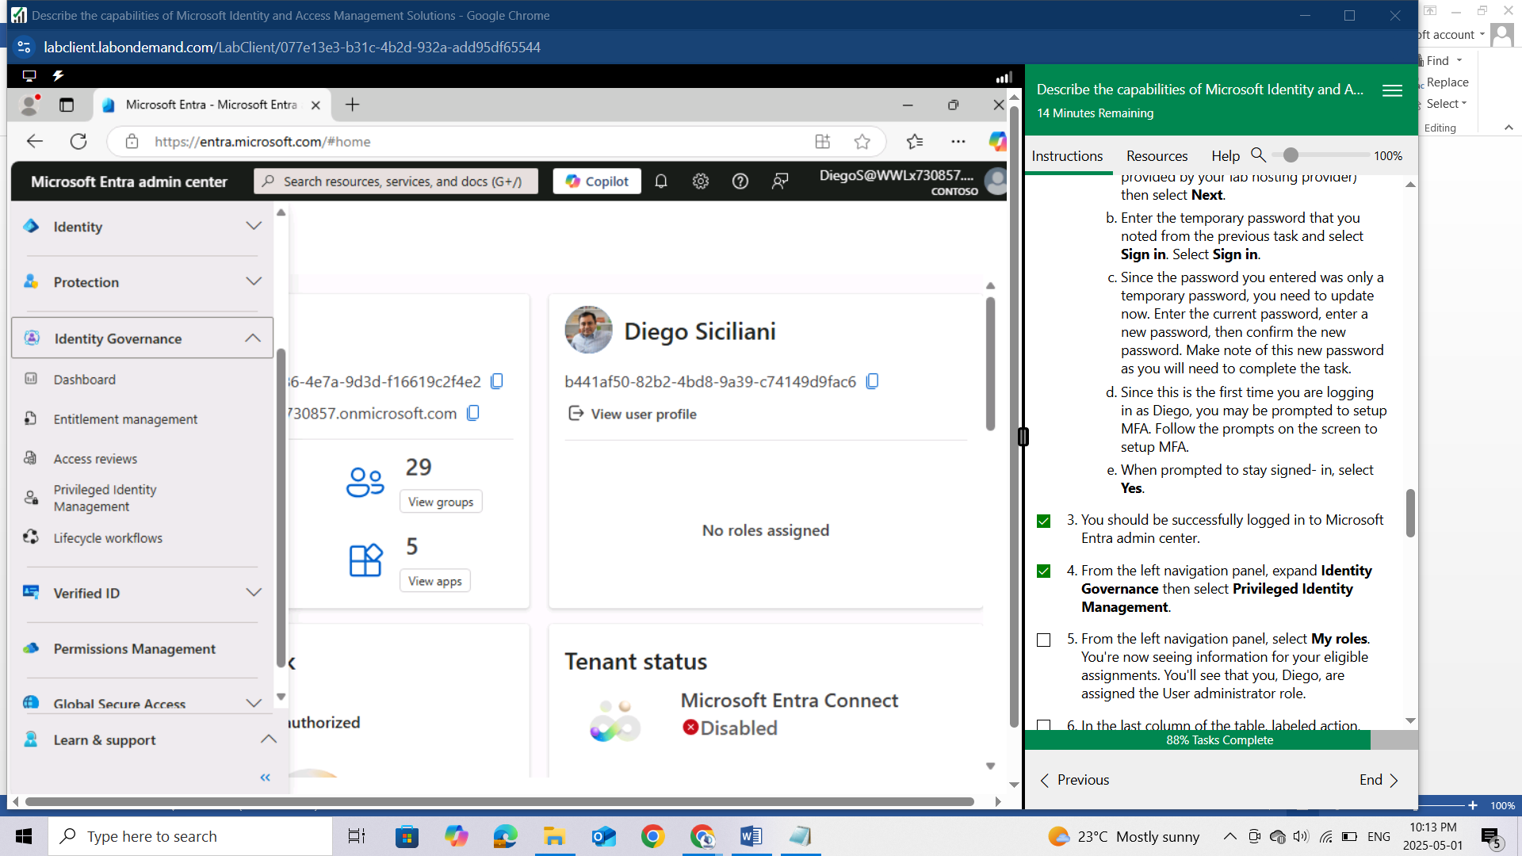

From the left navigation panel, select My roles.

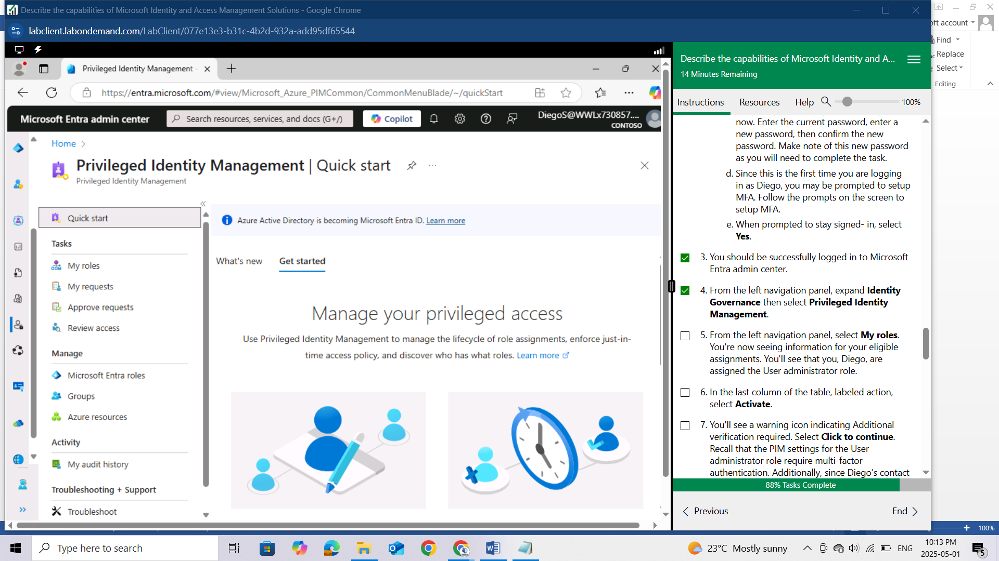

You're now seeing information for your eligible assignments. You'll see that you, Diego, are assigned the User administrator role.

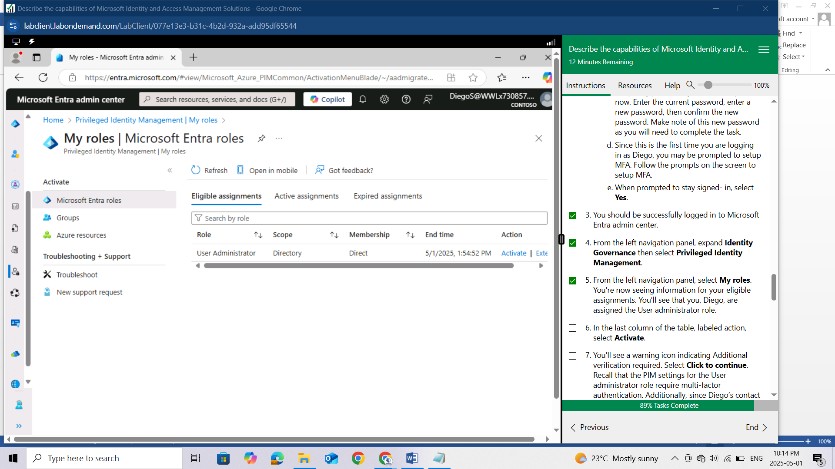

In the last column of the table, labeled action, select Activate.

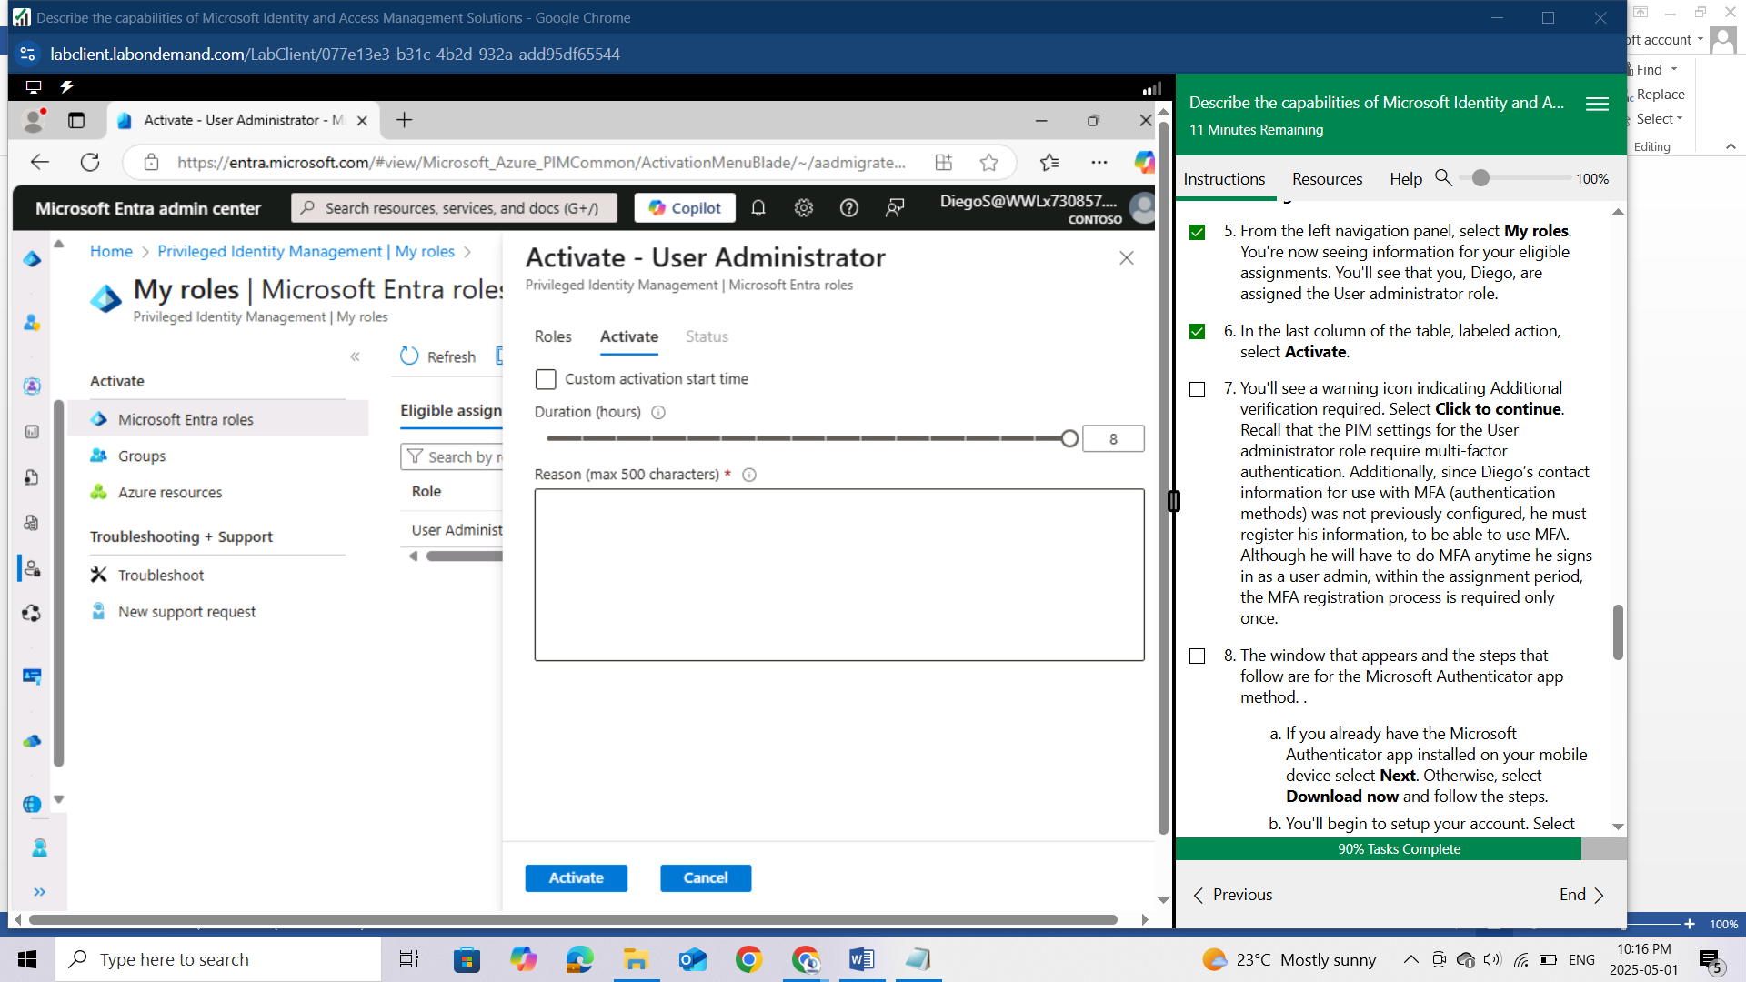

You'll see a warning icon indicating Additional verification required. Select Click to continue. Recall that the PIM settings for the User administrator role require multi-factor authentication. Additionally, since Diego’s contact information for use with MFA (authentication methods) was not previously configured, he must register his information, to be able to use MFA. Although he will have to do MFA anytime he signs in as a user admin, within the assignment period, the MFA registration process is required only once.

The window that appears and the steps that follow are for the Microsoft Authenticator app method. .

If you already have the Microsoft Authenticator app installed on your mobile device select Next. Otherwise, select Download now and follow the steps.

You'll begin to setup your account. Select Next.

Using the Microsoft Authenticator app on your mobile device, select the + to add an account and select Work or school account.

Select the option to Scan the QR code, then using your mobile device, scan the QR code on your PC screen .

Using the Microsoft Authenticator app on your mobile device, scan the QR code.

Follow the steps on your PC and mobile device, then select Next.

Once you've setup your security info, you'll see a Success window. Select Done.

Once you complete the MFA registration process, you are returned to the PIM Active-User Administrator page.

The Activate User Administrator window appears. You're required to enter a reason for the activation. In the box that appears, enter any reason you want (max of 500 characters), then select Activate.

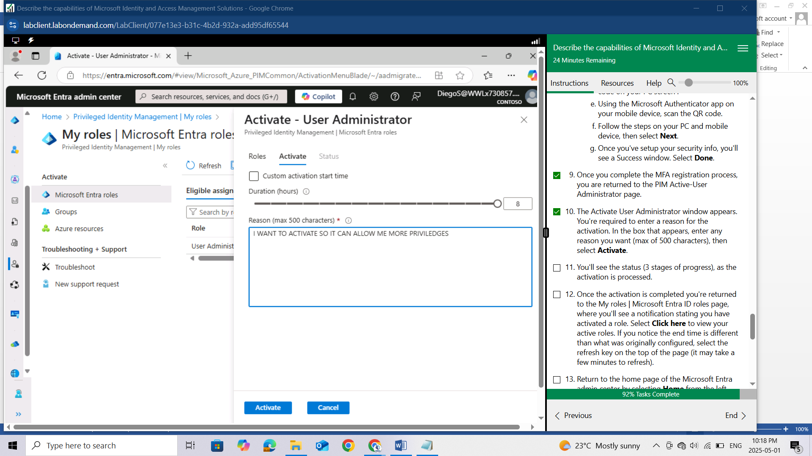

You'll see the status (3 stages of progress), as the activation is processed.

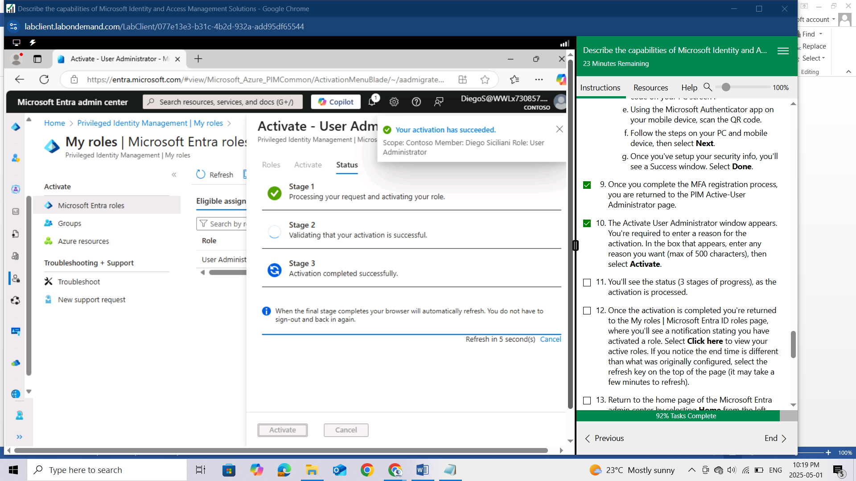

Once the activation is completed you're returned to the My roles | Microsoft Entra ID roles page, where you'll see a notification stating you have activated a role. Select Click here to view your active roles. If you notice the end time is different than what was originally configured, select the refresh key on the top of the page (it may take a few minutes to refresh).

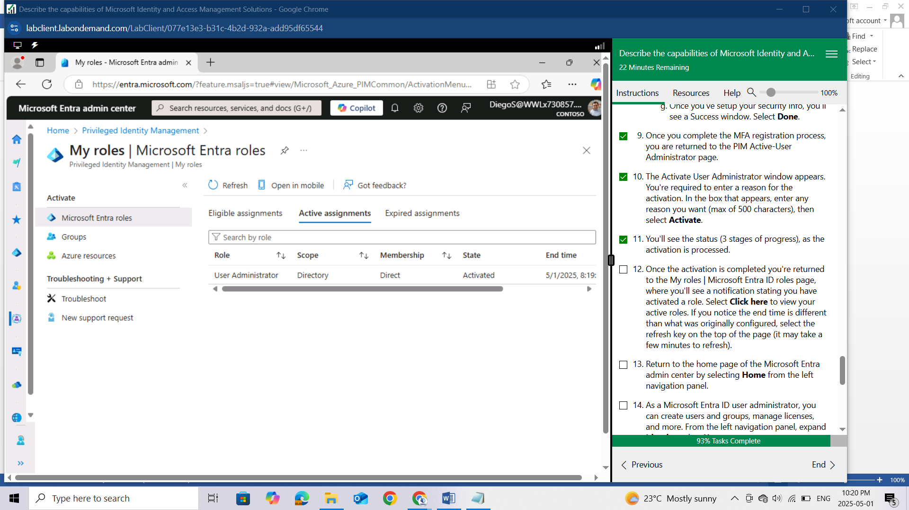

Return to the home page of the Microsoft Entra admin center by selecting Home from the left navigation panel.

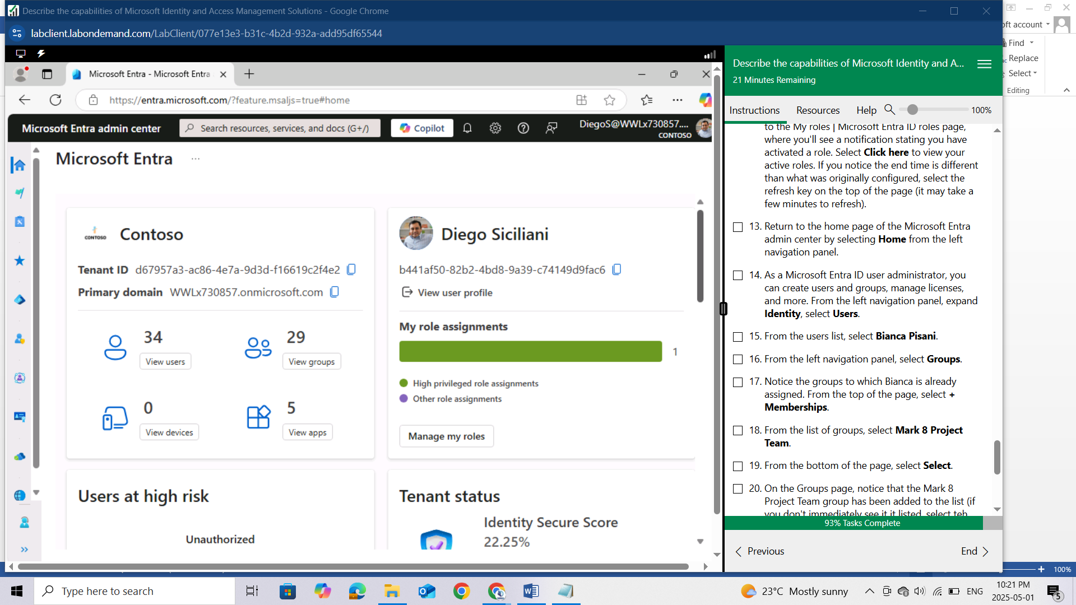

As a Microsoft Entra ID user administrator, you can create users and groups, manage licenses, and more. From the left navigation panel, expand Identity, select Users.

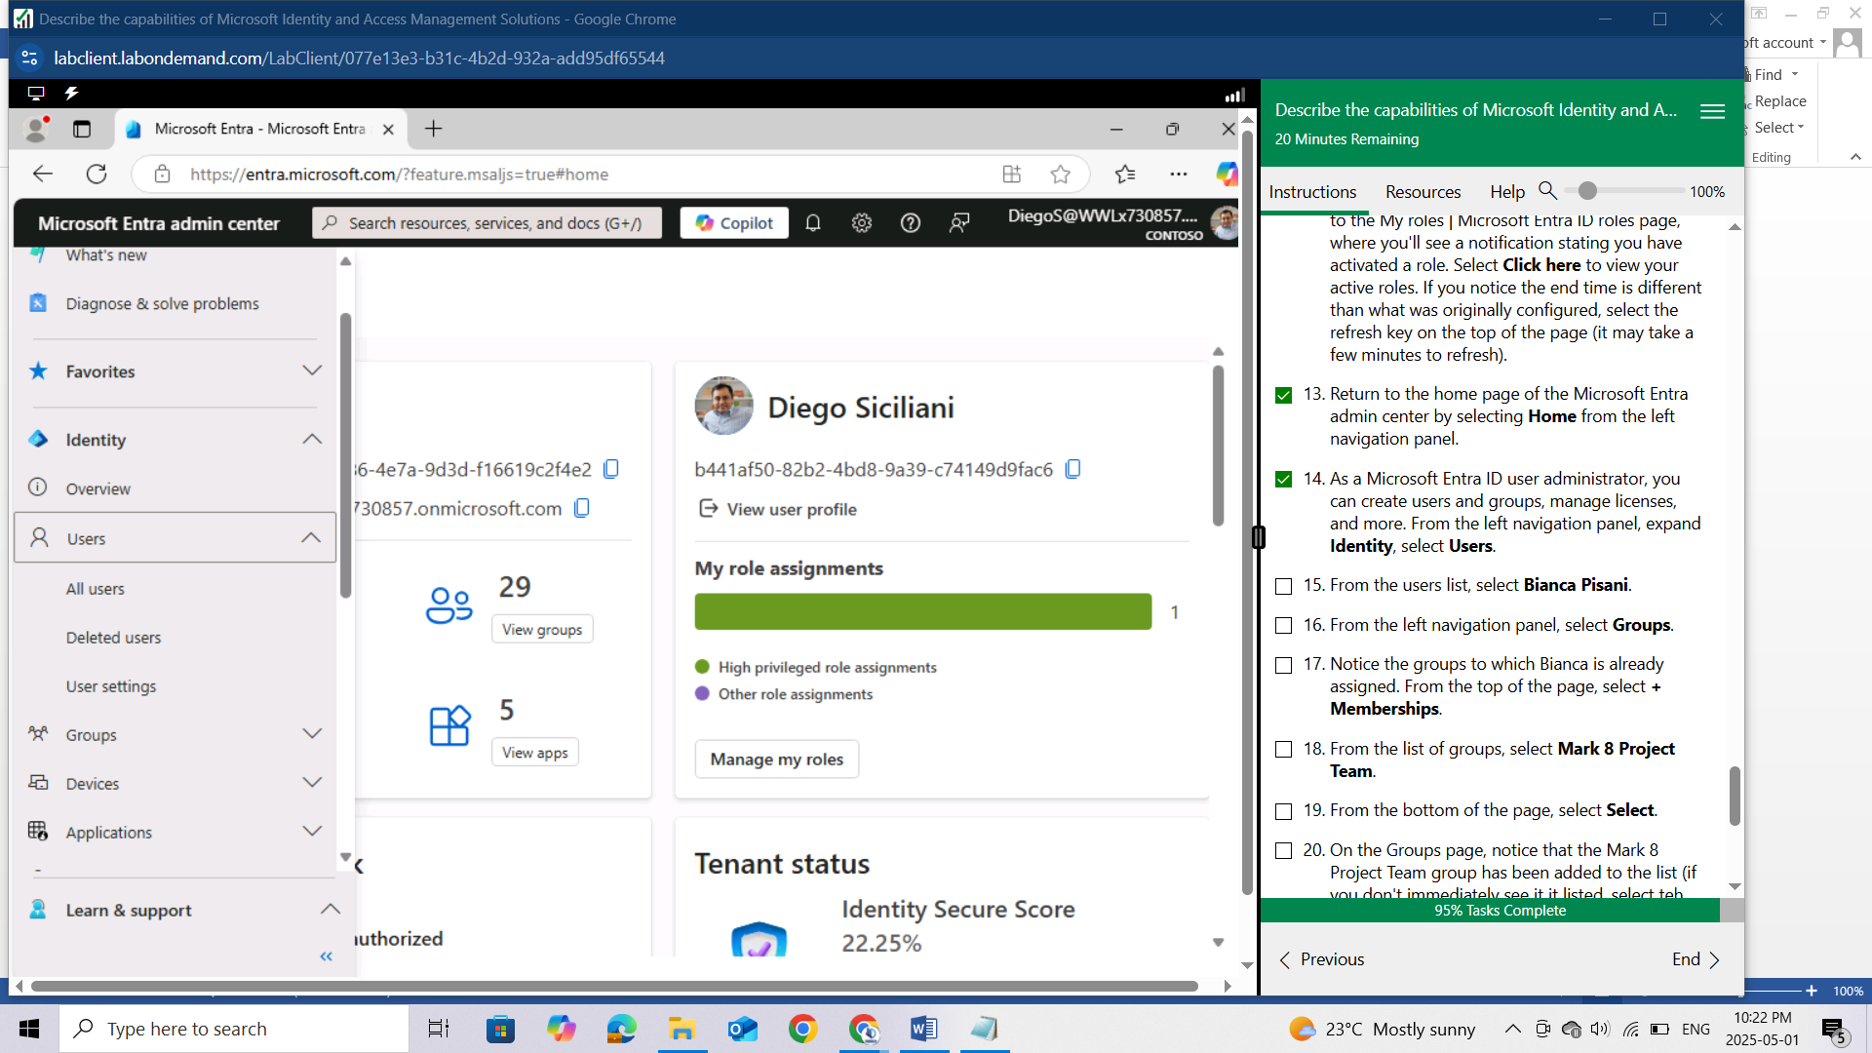

From the users list, select Bianca Pisani.

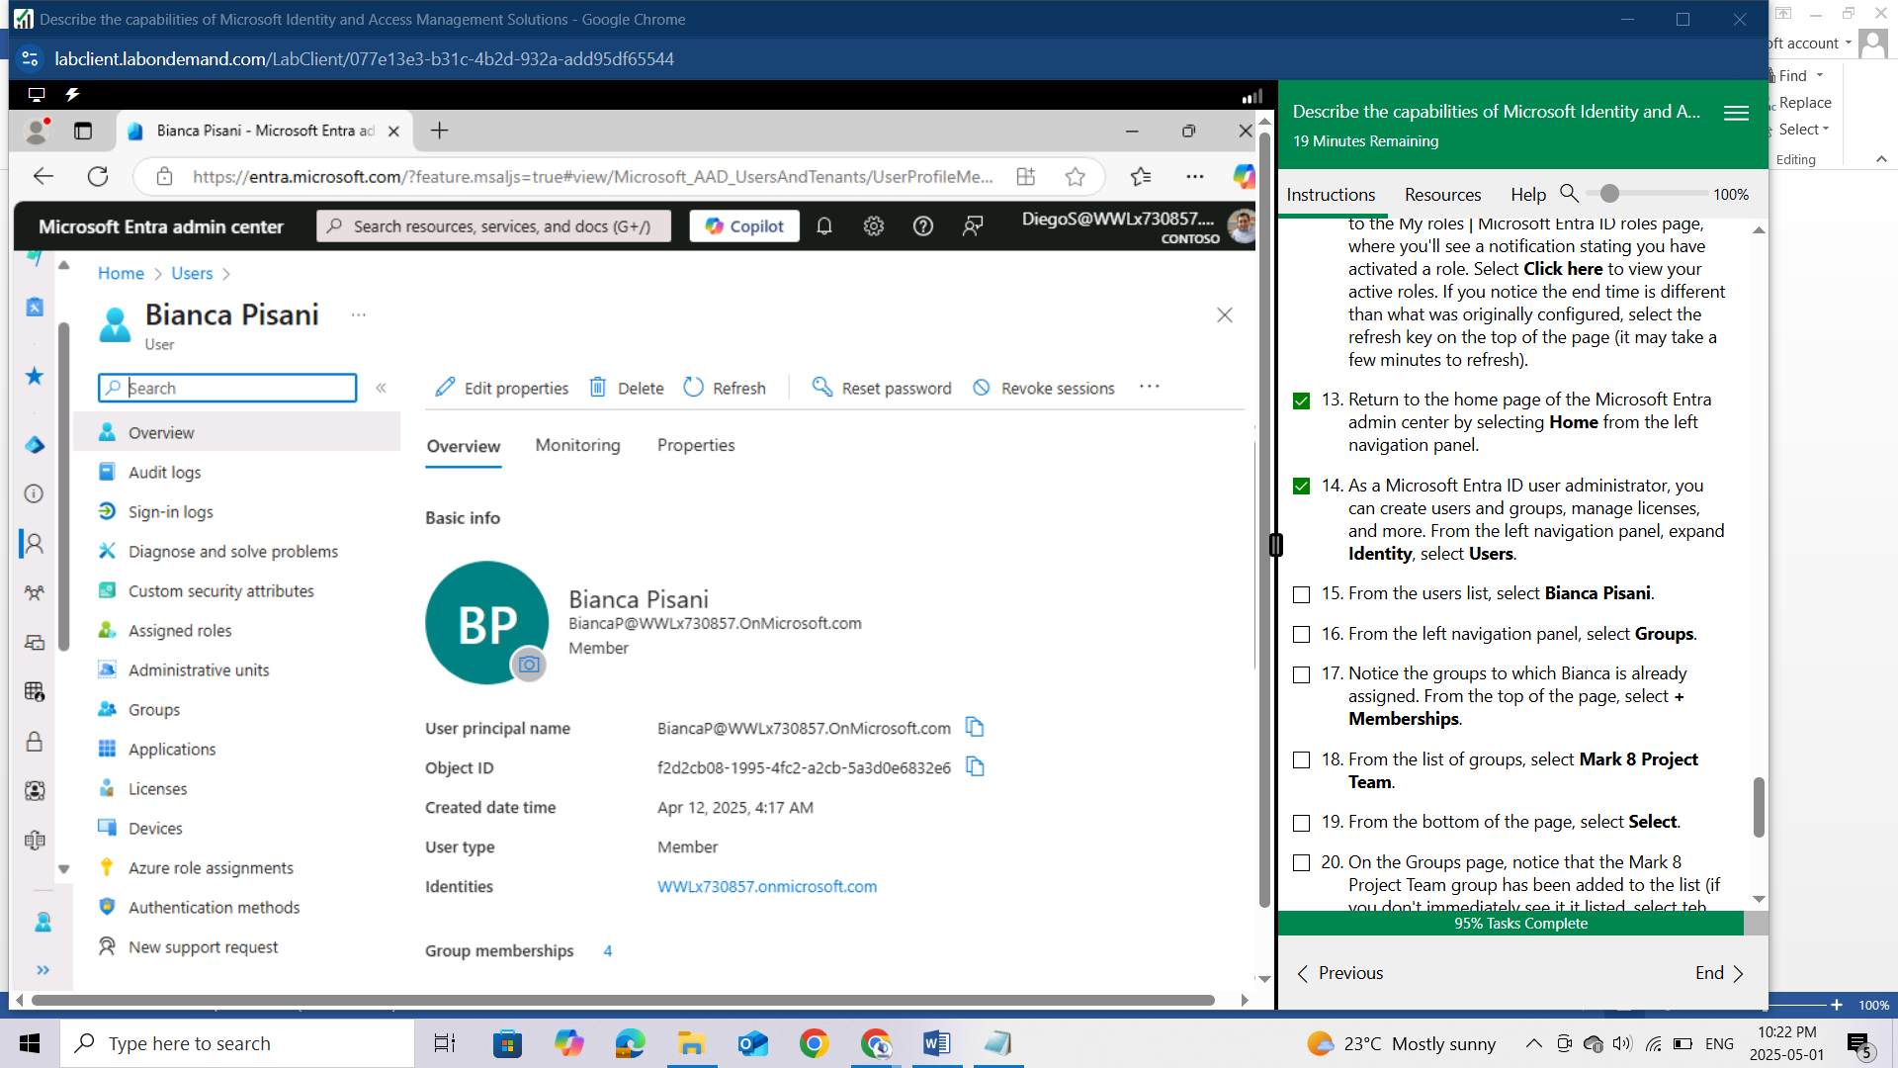

From the left navigation panel, select Groups.

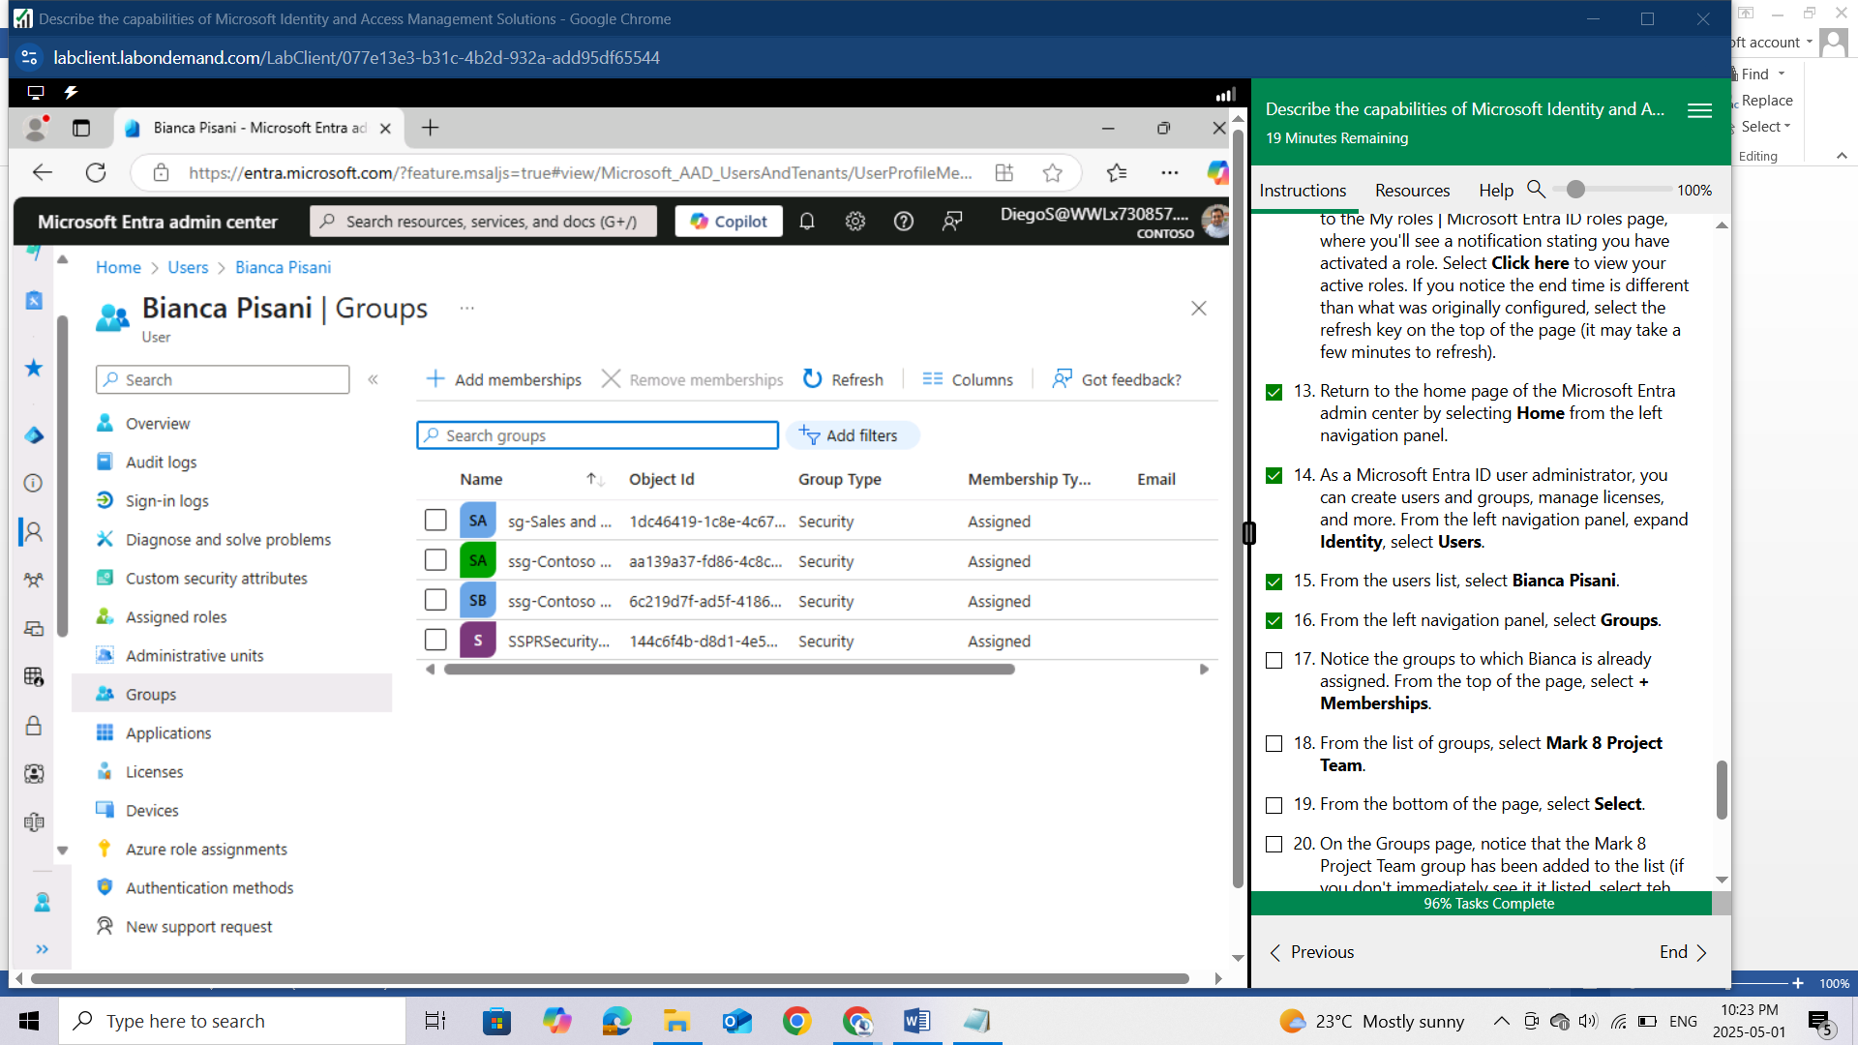

Notice the groups to which Bianca is already assigned. From the top of the page, select + Memberships.

From the list of groups, select Mark 8 Project Team.

From the bottom of the page, select Select.

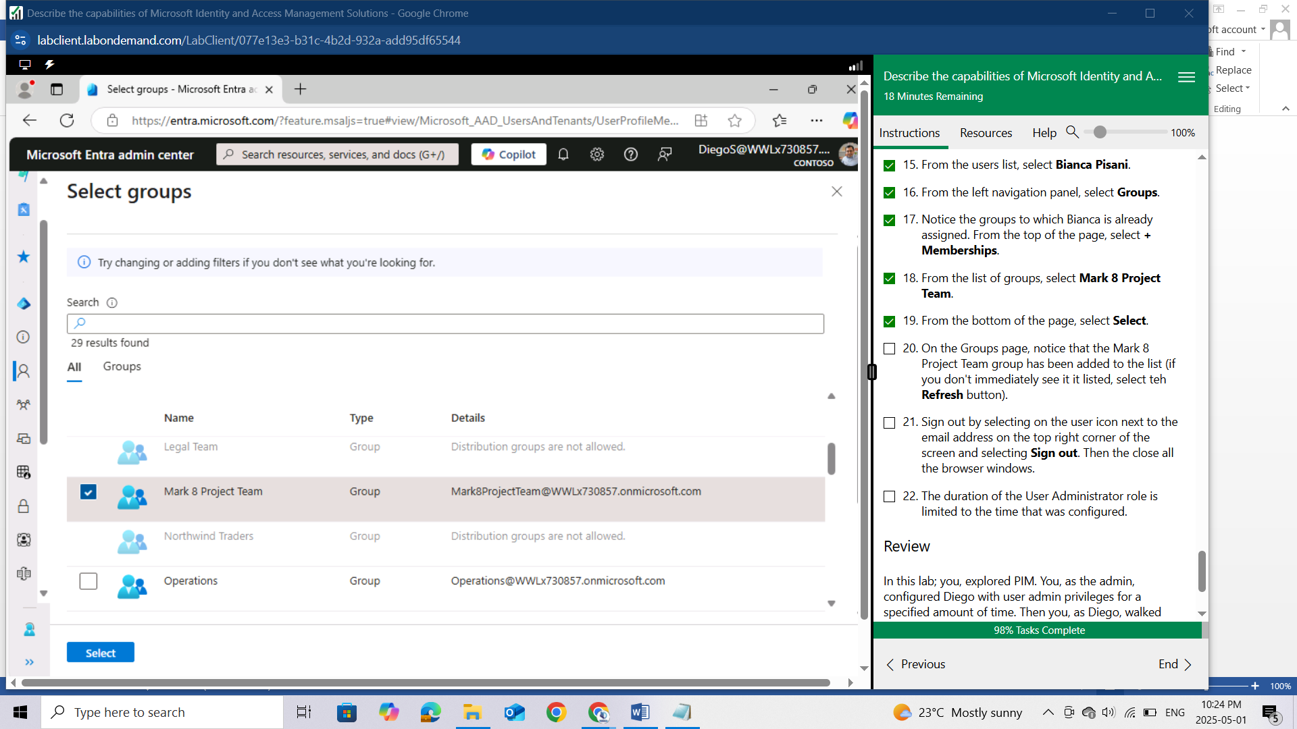

On the Groups page, notice that the Mark 8 Project Team group has been added to the list (if you don't immediately see it listed, select the Refresh button).

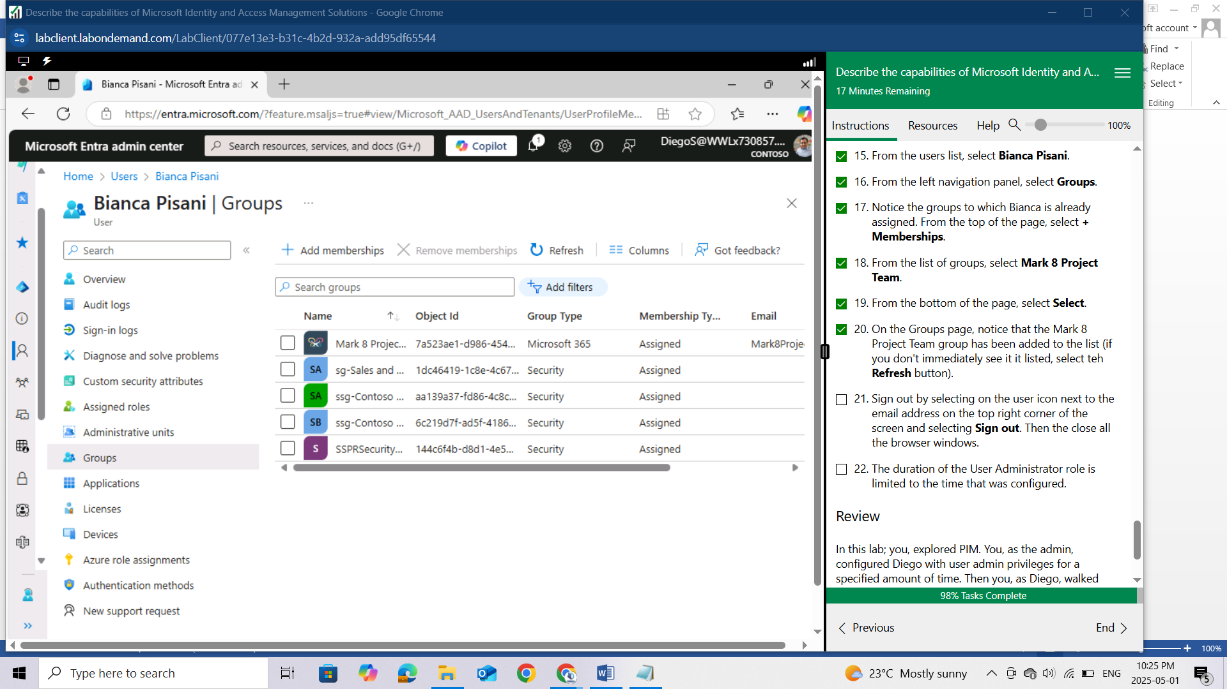

Sign out by selecting on the user icon next to the email address on the top right corner of the screen and selecting Sign out. Then the close all the browser windows.

The duration of the User Administrator role is limited to the time that was configured.

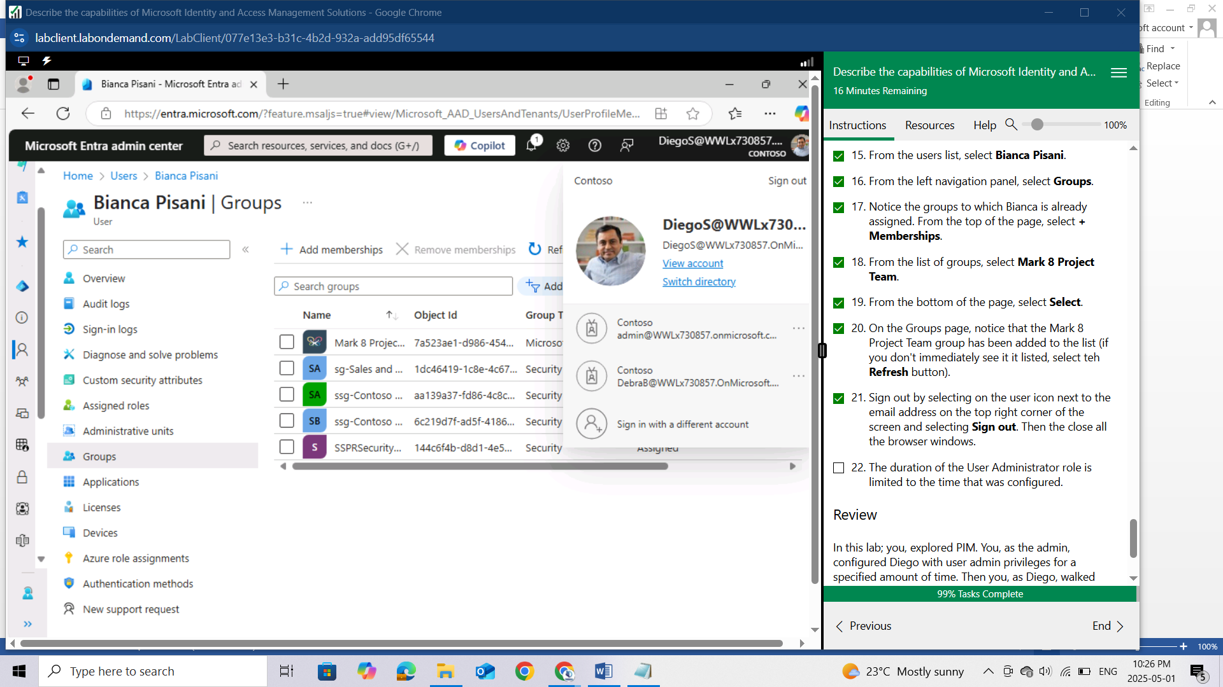

## Review

In this lab; you, explored PIM. You, as the admin, configured Diego with user admin privileges for a specified amount of time. Then you, as Diego, walked through the process of activating the user admin privileges and a user to a group. Recall that PIM requires Microsoft Entra ID Premium P2 licensing.